Xbox System Specifications
If you have questions or comments, contact your account manager.
Overview
The Xbox™ video game system Microsoft is a variation of the legacy-free personal computer architecture designed to target the game console and living room entertainment space. The product definition for the Xbox game system targets four key aspects: minimal retail price, excellent graphics and sound performance, enhanced television and game viewing, and Internet capability.
This document specifies the hardware design of the Xbox gaming console, including specification of the following system-critical design aspects:
- CPU
- Main memory cache capacity and performance
- Main memory capacity and bandwidth
- Boot ROM implementation
- 3-D accelerated graphics processor architecture, performance, and memory capacity
- 3-D accelerated audio processor
- Core logic implementation

- DVD specification

- Hard disk specification
- Audio and video outputs
- Universal serial bus (USB) implementation

- The architecture of Xbox is based on leading-edge computer technology. The architecture and performance of Xbox will remain constant throughout the life span of the product, which is estimated at approximately four years. Over this span of time, computer technology will continue to advance, while average computer prices will fall at a fairly low rate. The Xbox game system, however, will maintain consistent performance year after year, while decreasing the cost of manufacture and the retail price of the product.
The long-term requirements of the design are as follows:
- Fast time to market of initial design
- Rock-solid reliability
- Best-in-class performance compared to current personal computer designs
- Significantly better performance relative to contemporary game consoles
- Path to achieve cost reduction of 30 percent annually
- Uniform performance over time, independent of implementation
Xbox Architecture
The Xbox video game system consists of the Xbox console, one or more game controllers, an AV pack, a television monitor, and an audio reproduction system. Refer to figure 1 for the following description of the game system, the components involved, and their interconnection.
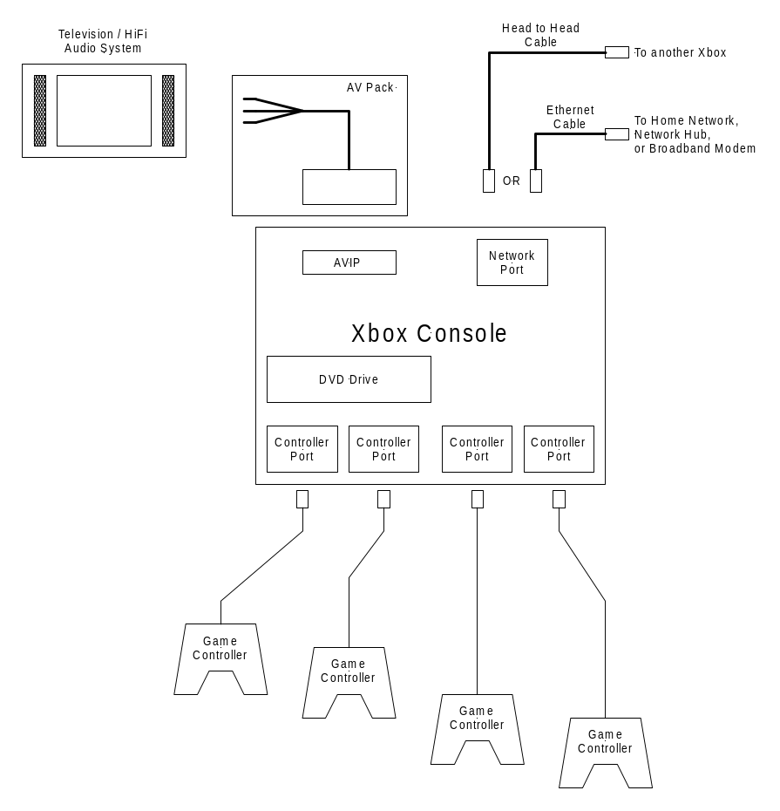
Figure 1 Xbox game system
The Xbox game console has three types of interface ports: controller ports, the audio video interface port (AVIP), and the network port. The controller ports, located on the front of the console, provide a means of connecting game controllers to the console. Game controllers are the user’s primary input devices for the console. The AVIP is a multi-pin connector that carries all the signals required to connect the Xbox console to a television and audio system. The Xbox game system supports many types of interconnection methods through use of an AV pack. An AV pack is an accessory device that adapts the AVIP to the particular needs of the user’s audio/visual system. AV packs provide composite video and line level audio signals, RF-modulated signal, and high-quality component video signals.
The network interface port provides a means of networking several Xbox consoles together for head to head or group game play. Networking may be peer-to-peer, local area network, or broadband via the Internet.
Xbox Console Architecture
Figure 2 shows the system-level block diagram of the Xbox console.
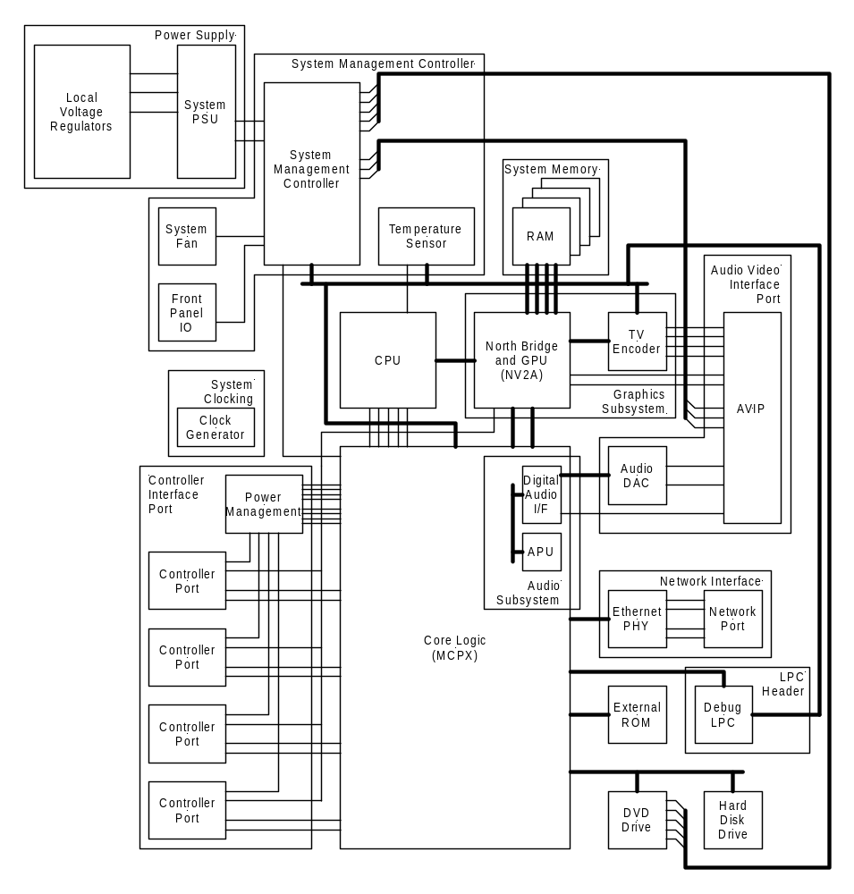
Figure 2 Xbox system block diagram
The remainder of the Overview section describes the features of the Xbox console design. The Design Specifications and Accessories sections will describe the detailed design and implementation guidelines and the performance specifications required to implement the described feature set.
Front Panel Features
Power Switch
The power switch is a momentary type push switch. The switch is monitored by the System Management Controller (SMC). The SMC controls the system startup and shutdown cycle. The design allows for soft startup and shutdown, allowing the system to perform system cleanup operations prior to shutdown. At the same time, the SMC guarantees the system will shut down reliably in the case of a system crash.
The Xbox game system does not implement any meta power states. The console itself is either “on” or “off,” although the SMC is always on as long as mains power is applied.
Game Controller Ports
Four front-mounted game controller ports are required. Electrically, each port appears as a full-speed upstream controller port, but mechanically, the connector is proprietary. The proprietary connector is designed to meet the Xbox product requirements for pull force and cycle life.
Disk Eject
The disk eject button is also monitored by the SMC. This allows the disk eject function to be operated even if the power is “off,” so long as mains power is applied.
Indicator Lights
The POWER switch is surrounded by a light pipe illuminated with an array of red and green LEDs. The LEDs are controlled by the SMC based on the SMC state machine and software settings requested by the CPU. The behavior of these LEDs is described in detail in the section System Management Controller.
Rear Panel Features
Power IN
The power input will be AC line power via a removable 2-pin line cord conforming to IEC-60320 2.5A Plug Connector for Class II Equipment. The input voltage range will be constrained to 110V or 240V depending on the regional market in which the console is sold.
The power supply is fully described in the Power Supply section of this design specification.
Audio Video Interface Port
The AVIP is a multi-pin port consisting of all electrical input and output ports supported by the graphics processor and audio codec. The AVIP includes video output signals, audio output signals, and selector inputs used to identify the type of adapter connected to the AVIP port.
By setting the logic states of the AVIP inputs, the adapter may select CVBS + Y/C (NTSC, PAL, or SECAM), or CVBS + RGB (PAL SCART) outputs. The AVIP has two audio interface ports, one for line-level stereo audio (left and right channels), which is output directly, and one for logic-level SP-DIF output, which is provided for interface to an external coaxial cable or fiber optic driver.
Network Interface
The network interface is implemented as a 10/100-Base T (RJ-45) Ethernet port. This port is intended for use with broadband Internet connections such as cable modems or Digital Subscriber Line (DSL) modems, home networks, and peer-to-peer networking. The PHY layer and MAC will support 10 and 100 megabits per second (Mbit/sec) operation (IEEE 802.3u).
Design Specifications
Central Processing Unit
The Xbox game system contains an Intel CPU. Features of the CPU include the following:
- MMX and SSE instruction set enhancements
- 733-MHz internal clock rate
- 133-MHz front-side bus
- 32-KB L1 cache
- 128-KB full-speed L2 cache integrated on-die
- BGA-2 package
- Manufactured in a 0.18μ process in the first year of production, with possible die shrink in following years
- JTAG
System Memory
Xbox uses a unified memory architecture (UMA) to consolidate the system RAM and graphics RAM into a single memory pool. An advanced memory controller and bus arbitration unit bridges the CPU system bus and the graphics processing unit (GPU) system bus and provides high-speed access to the unified memory pool.
The system will use double data rate synchronous dynamic random access memory (DDR SDRAM). DDR SDRAM transfers data words at a sustained 400 MHz, using both edges of the 200-MHz memory clock.
The size of the unified memory pool is 64 MB. The memory space is divided into four fully independent memory channels, each 32 bits wide and capable of four open pages of memory.
The RAM integrated circuits (ICs) will be soldered directly onto the motherboard to eliminate the need for sockets and dual inline memory modules (DIMMs). The board layout will incorporate eight 2 MB × 32 ICs, two on each of the four data channels. The two ICs on each bus will be located opposite each other on the top and the bottom side of the board, with connections made between the closest pins. Because address and data pins will be crossed in this configuration, the memory controller will compensate by multiplexing the pin assignments depending on whether it is accessing the top-side or bottom-side IC. Future redesigns of the motherboard for the Xbox game system may migrate to 4 MB × 32 ICs, but the total number of open pages will remain the same.
Boot
Xbox does not have a traditional basic input/output system (BIOS) such as that found in a traditional computer. Instead, Xbox boots directly from a flash-RAM or ROM containing hardware initialization code, the system software kernel, and hardware abstraction layer. Early production units will implement the system software memory as flash memory, but later units will migrate to a ROM-based component to minimize cost. The system software memory will not be field-upgradable or modifiable by the user without electrical intervention.
The system software will occupy no more than 2 MB of ROM. The system software memory is interfaced through the core logic.

Graphics Subsystem
The graphics subsystem consists of a high-performance memory controller integrated with an advanced graphics processor and a digital video interface to the television encoder. The television encoder includes digital scaling and encoder logic as well as the digital to analog converters (DACs) for producing NTSC/PAL/SECAM television signals.
The graphics processor is integrated with the north bridge functionality to implement a UMA. The north bridge consists of a memory controller, a P6 front-side bus interface, a lightning data transport (LDT) interface, and an arbitration unit to route transactions across the CPU, GPU, LDT, and memory buses. The bus connecting the arbitration unit and the GPU memory bus is internal to the IC. The LDT interface is used to bridge to the companion core logic chip containing the lower-bandwidth logic functions such as Advanced Technology Attachment (ATA), universal serial bus (USB), Xbox ROM, and the audio processing unit (APU). These functions are described in more detail in the Core Logic (MCPX) section.
The performance level of the graphics processor is representative of Microsoft® DirectX® 8.0 class computer products. The overall system performance is a function not only of the graphics processor but also of the buses that interconnect the graphics subsystem and the CPU. The detailed performance criteria for the graphics subsystem components are described in the following sections.
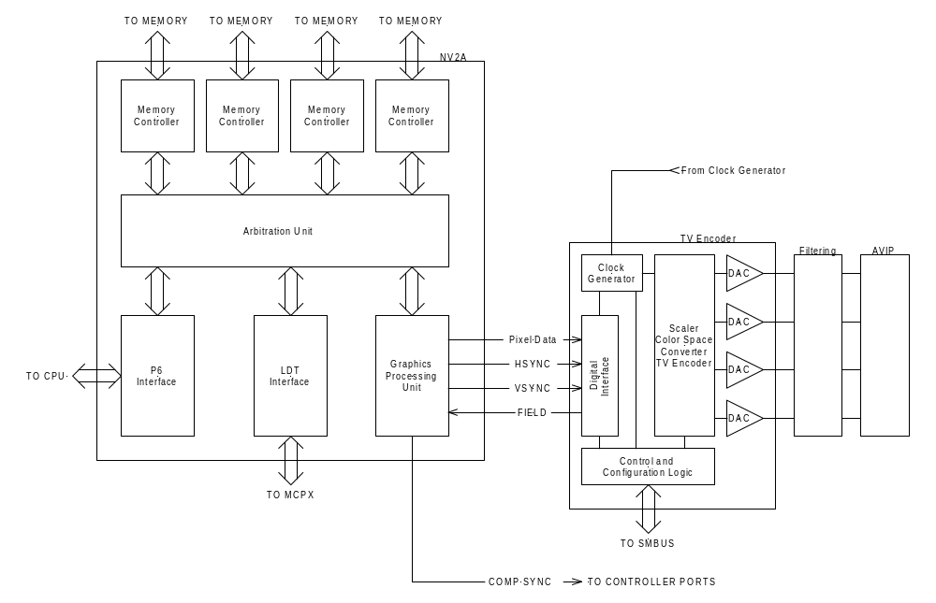
Figure 3 Graphics subsystem block diagram
North Bridge and GPU (Xbox GPU A-2)
The Xbox Alpha 2 Graphics Processing Unit (Xbox GPU A-2) is an integrated north bridge memory controller and graphics processor unit. The Xbox GPU A-2 contains four independent memory controllers for the unified system memory, a GPU, a P6 front-side bus interface to the CPU, an LDT bus interface to the core logic, and an arbitration unit to manage memory and interbus transactions.
Graphics Processor
The graphics processor consists of the transformation and lighting engine, a pixel processing pipeline, and a rasterization unit. Included with these blocks are the memory controllers, cache controllers, and logic to connect the various computational blocks. The rasterization unit outputs a digital video signal as a parallel bit stream clocked by the pixel clock or some multiple of the pixel clock.
For a detailed description of the GPU, see the “Xbox Graphics Subsystem” specification.
Integrated North Bridge
The integrated north bridge functional block provides the system memory controller, P6 front-side bus interface, LDT bus interface, and the arbitration unit functionality. This block arbitrates between the CPU system bus and the GPU memory bus. It also processes the memory transactions to and from the unified memory pool. The memory controller also bridges the CPU system bus to the Peripheral Component Interconnect (PCI) local bus for interface to the peripheral logic and input/output (I/O) controllers.
The unified memory pool is implemented in 200-MHz DDR SDRAM.
Front-Side Bus Interface
The front-side bus interface to the CPU will be a P6 bus clocked at 133 MHz.
LDT Bus Interface
The LDT bus is a high-speed, low pin-count bus with dedicated upstream and downstream transfer channels. The bus is capable of combined transfers of up to 800 MB/sec (400 MB/sec up and 400 MB/sec down simultaneously).
Digital Video Interface
The digital video samples will be output to the TV encoder via a 12-bit parallel digital video interface, clocked on both edges. The output format is 4:4:4 YCrCb.
The GPU will supply HSYNC and VSYNC signals to the TV encoder, but the TV encoder will supply the pixel clock. The GPU will output a composite sync signal used to drive the sync output of the controller ports.
Clock Generator
Clock input:
- 13.5 MHz
Clock outputs:
- 250/300 MHz – GPU Core
- 200 MHz – DDR, LDT
- 133 MHz – CPU
TV Encoder
The TV encoder takes as input digital video signals over a parallel digital interface from the GPU and outputs analog CVBS/Y/C signals. The TV encoder section converts the analog component signals and outputs the appropriate signals to drive a television monitor, or a computer monitor, based on the settings of the configuration registers. The configuration registers are programmed via an I²C bus connected to the core logic chip.
The TV encoder will be capable of outputting all of the following modes:
- Composite and S-video NTSC, PAL, or SECAM
- Composite PAL and component RGB (625/50) for SCART operation

- The TV encoder supports selective application of Macrovision anti-recording signals as follows: for NTSC and PAL output modes, Macrovision 7.01 anti-recording is applied to the composite and S-video outputs.
The output signals are driven on to the AVIP connector by 75-ohm cable driver amplifiers. Anti-alias filtering and EMI suppression filtering is accomplished via off-chip filter networks as described in detail in the section Audio Video Interface Port (AVIP).
Digital Video Interface
- 12-bit parallel
- Dual-edge clocked
- 1.2-V signaling
- H/V/field to be supplied by the GPU CRT controller logic, pixel CLK to be generated by the TV encoder
Additional Features
- Macrovision 7.0 or better for CVBS and Y/C outputs
- Wide screen signaling
- Copy generation management system
Video Input Modes
- 24-bit RGB
- 24-bit 4:4:4 YCrCb

- Video Output Modes
The television modes used by country are tabulated in Appendix C of this document. For video output support in the countries where the Xbox game system is to be marketed, the TV encoder will support the following video output modes:
- NTSC-M (CVBS + Y + C)
- PAL-I (CVBS + Y + C)
- PAL-I (CVBS + R/G/B)
- SECAM-L (CVBS + Y + C)

- Conversion Mode Matrix
The TV encoder will support the combination of input and output modes shown in table 1.
Table 1 Video output conversion matrix
Frame Buffer Configuration |  |  | NTSC | PAL  SECAM
Pix | Line | Frame (Hz) | NTSC | PAL  SECAM
640 | 480 | 59.94 interlaced | •
704
720
640 | 480 | 59.94 progressive | •
704
720
640 | 480 | 50  progressive |  | •
704
720
640 | 576 | 50  interlaced |  | •
704
720

Analog Video Output Multiplexing
The TV encoder provides four video DAC outputs. To support all the composite, S-video, and component modes, the four outputs must be multiplexed. The DAC multiplex table is shown in table 2.
Table 2 DAC output allocations
DAC Output | SDTV Mode | SCART Mode
DACA | Y | G
DACB | C | R
DACC | Not Used | B
DACD | CVBS | CVBS

Each TV encoder DAC output is capable of driving a single 75-ohm terminated load. Passive filtering is required to minimize EMI and spectral aliases arising from the digital to analog conversion. The filter arrangements and characteristics are described in the Audio Video Interface Port (AVIP) section.
Audio Subsystem
The audio subsystem consists of an audio processing unit (APU) and a digital audio interface controller. The APU and digital audio interface controller are integrated into the system core logic chip.
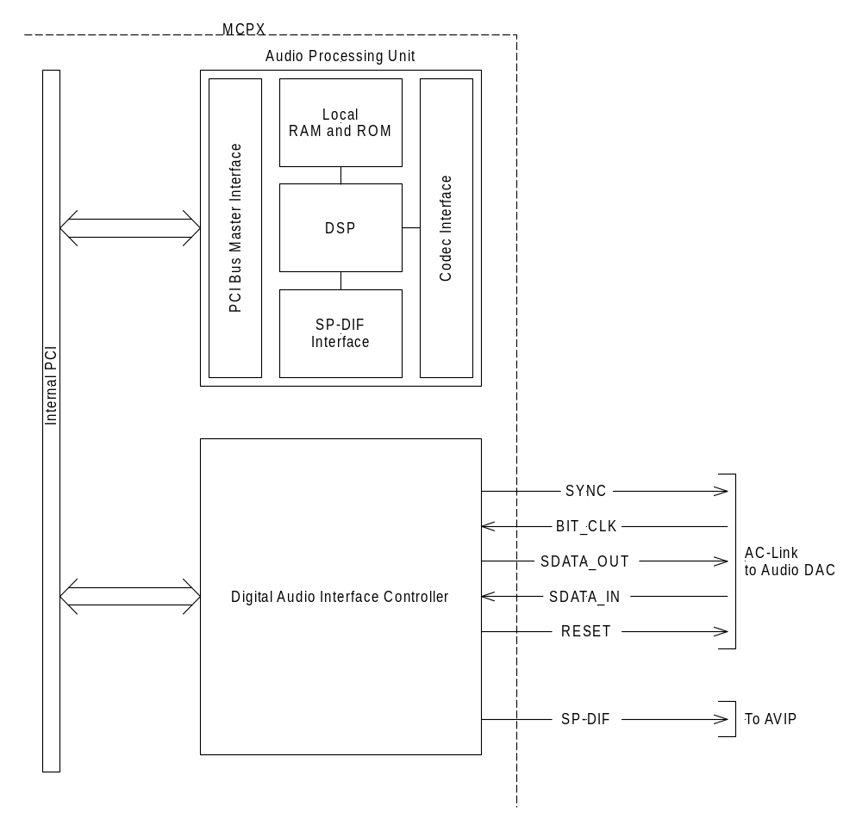
Figure 4 Audio subsystem block diagram
The capabilities of the audio subsystem include the following:
- Advanced audio processor—synthesis, effects, and mixing operations are performed by a dedicated APU.
- AC-Link out—the audio subsystem will output two-channel AC-Link audio to the audio DAC. The performance and characteristics of the DAC are described in the Audio Video Interface Port (AVIP) section.
- Electrical SP-DIF output—the audio subsystem will provide electrical SP-DIF output for interface to an external optical SP-DIF driver. The optical SP-DIF transmitter will be implemented as part of an AV expansion pack as described in the Accessories section.
The specifications of the individual audio subsystem components are detailed in the following sections.
Audio Processing Unit
The APU is integrated into the core logic chip (MCPX). The APU consists of a fixed-function digital signal processor (DSP) and two programmable DSPs. The DSPs can access audio streams in system memory, have local code and data memory, and output the processed streams back to system memory for output via the AC-Link and SP-DIF interfaces.

Input Formats  1 to 18 samples per block  8-, 16-, and 32-bit containers | Output Formats  1, 2, 4, or 6 samples per block  16- or 32-bit containers
DirectX 8.0 Capabilities
Submix bins
2nd pass processing

2-D Wave  Microsoft® DirectSound®, WAVE  Per-voice filtering | 3-D Support  Head-Related Transfer Function with cross talk  I3DL2 reverb  Occlusion and obstruction  Near field effects
DLS1/2 Support  Two envelope engines w/LFO  Downloadable Sounds (DLS) filtering  Pan, pitch, vibrato, and tremolo  Reverb and chorus send | Voice Support  256 total hardware voices  64 3-D voices with cross over  32 DirectX 8.0 submix voices with hardware submixing 160 2-D/WT voices, all DLS-2 capable  20 effects and input voices
Performance
133-MHz clock frequency
Fixed-function 24-bit DSP @ 2,000 millions of instructions per second (MIPs)
Programmable-function 24-bit DSP @ 500 MIPs for effects processing
Programmable-function 24-bit DSP @ 500 MIPs for multispeaker audio effects
+85 dB with 16 bps inputs
24-bit sample processing paths
32-bit mixing
Figure 5 APU feature summary
Digital Audio Interface Controller
The Digital Audio Interface Controller provides the direct memory access (DMA) engine and interface for outputting the processed audio streams to the audio outputs. The audio subsystem provides digital audio in two formats: SP-DIF and AC-Link.
The AC-Link interface complies with revision 2.1 of the AC-Link interface specification. The AC-Link digital audio stream is converted to an analog signal by an audio DAC. The DAC, post filtering, and audio performance characteristics are described in detail in the Audio Video Interface Port (AVIP) section.
The AC-Link drives an AC-97 audio codec that provides analog line-level audio outputs to the AVIP. The details of the DAC and related signal conditioning circuits are detailed in the Audio Video Interface Port (AVIP) section.
The audio subsystem outputs a logic-level (3.3-V) SP-DIF signal that is presented to the AV interface connector. This signal is conditioned in the AV pack for electrical or optical transmission via coaxial cable or optical fiber.

Core Logic (MCPX)
The core logic, or media communication processor (MCPX), contains all of the core logic functions, including the audio processor and interface controller, hard disk and DVD drive interfaces, peripheral port controllers, and system support functions. The MCPX connects to the GPU via an LDT bus that provides a transfer rate of 800 MB/sec. The individual logic blocks integrated into the MCPX core logic chip are described in the following sections, as is the functionality of the core logic functions.

Audio Processor and Digital Audio Interface
These logic blocks are described in the Audio Subsystem description.
ATA Interface
The MCPX implements a single ATA-100 port with scatter-gather mastering. The master supports three transfer modes:
- Programmed input/out (PIO) mode 0, 1, 2, 3, and 4
- DMA mode 0, 1, and 2
- UDMA-33, 66, and 100
The motherboard and cable assemblies in the Xbox console will be designed only for ATA-33 operation, using the DMA-33 transfer mode.
USB Host Controller
The MCPX implements a USB host controller compatible with the Open Host Controller Interface (OHCI) 1.0a implementing the Universal Serial Bus Protocol version 1.1. The host controller is mapped to the four game controller ports.
The USB differential transceivers are implemented directly on the core logic IC. Power management and overcurrent protection are provided by external power management ICs. The host controller monitors the overcurrent flags from the power management circuit. The port power enable signals are controlled on each port individually by general purpose input/output (GPIO) pins.
Ethernet Media Access Control
The Ethernet media access control features dual-speed Carrier Sense Multiple Access with Collision Detection (CSMA/CD) for 10- and 100-Mb/sec operation as defined in IEEE 802.3u. The media access control includes a Media Independent Interface (MII) to an external PHY.
The media access control includes the following features:
- Provides transmit first in, first out (FIFO) to provide frame buffering for increased system latency, automatic retransmission with no FIFO reload, automatic transmit padding, and FCS generation
- Provides receive FIFO to provide frame buffering for increased system latency, automatic flushing of collision fragments, automatic receive pad stripping, and a variety of address match options
- Supports unicast, multicast, and broadcast addressing
- Supports filtering for at least 16 multicast addresses
- Offers two-part deferral algorithm
- Recognizes late collision
- Provides internal and external loop-back
MII features:
- Complies with IEEE 802.3u (MII/RMII)
- Supports half- and full-duplex operation
- Controls and receives status from external PHY through the MII management interface
- Supports auto-negotiation through the external PHY
- Supports automatic polling of the status of external PHY status including link status, auto-negotiation ability, and half- and full-duplex ability.
External ROM Interface
The MCPX will support addressing of up to 16 MB of external flash ROM, electrically erasable programmable read-only memory (EEPROM), or masked ROM. The interface is implemented as a simplified Xbox bus interface, with only memory read/write capability and no interrupt or DMA support.
The bus consists of the following pins:
- ADDRESS[21..0]—22 address lines to address a total of 4 M addresses
- DATA[7..0]—8 data lines for reading and writing data from and to the bus
- CS—a single chip select to qualify access cycles
- MEMR—a memory read qualifier signal
- MEMW—a memory write qualifier signal
General Purpose I/O Pins
The MCPX implements nine GPIO pins. The GPIO pins provide software control of functions by the CPU. Refer to the MCPX data sheet for detailed information.
The mapping of GPIO pins is shown in table 3.

Table 3 GPIO pin usage
GPIO | Signal Name | Direction | Comment
0 | FWENB | OUT | This pin is reserved to allow for in-system re-programming of the flash ROM in development systems only. This pin will not be terminated in the retail version of the product.
1 | VBUSENB1 | OUT | These pins provide per-port control of the VBUS power enable for each of the five controller/expansion ports.
2 | VBUSENB2 | OUT
3 | VBUSENB3 | OUT
4 | VBUSENB4 | OUT
5 | VBUSENB5 | OUT | This pin provides port control of the VBUS power for the fifth port. This port is installed only on development units.
6
7
8 | LVLCNT0 | OUT | These pins provide control of the SCART STATUS output of the AVIP port.
9 | LVLCNT1 | OUT

LPC Interface
The MCPX implements an LPC interface for bridging to legacy Industry Standard Architecture (ISA) devices for development purposes or as an alternative boot ROM interface.
The LPC interface provides an alternative means of connecting the boot ROM to the MCPX. For the first year design, the boot ROM will be accessed via the external ROM interface described previously. The motherboard will implement an LPC header to support debugging devices to be connected for development purposes, and to aid in troubleshooting during manufacturing line rework.
LDT Bus
Data transfers between the Xbox GPU A-2 and MCPX are carried over a full-duplex LDT data bus. This bus consists of two links, one serving transfers from Xbox GPU A-2 to MCPX, the other serving transfers from MCPX to Xbox GPU A-2.
- High speed—low pin count
- Differential—unidirectional bus
- 800 MB/sec peak (scalable)
- Efficient pipelined architecture for low latency
- Support multiple outstanding split transactions
- Flat/fair arbitration
- Legacy and non-legacy master recognition
- Isochronous and asynchronous queue
- Pipeline reads and writes
Clock Generator
The clock generator module in the MCPX takes as input a stable clock reference (F_{REF}) and uses multiple phase-locked loops to generate clocks for the other blocks in the MCPX. The system-level clocking architecture is described in detail later in this document.
Input frequency:
- CLK13P5
Output frequencies:
- 200 MHz – LDT
- 100 MHz – LDT bus interface, APU bus interface, USB bus interface, Ethernet media access control, legacy block bus interface
- 166 MHz – APU core
- 48 MHz – USB DPLL
- 33 MHz – legacy block
Real Time Clock (RTC)
The MCPX implements a real-time clock (RTC) that may be powered by an external primary lithium coin cell. The RTC provides a real-time reference for date and time of day as well as a small amount (256 bytes) of battery-backed RAM for storage of system parameters.
The RTC includes a 32.768-kHz oscillator, a clock and calendar timer, an alarm (which generates an interrupt when a specified time occurs), and 256 bytes of nonvolatile RAM. It is register compatible with the RTC found in the original AT design (which used the MC146818).
Power
The RTC includes its own power plane, VRTC, which is powered by an external 1.5-volt lithium battery. An external diode network allows the RTC to power from the 3VSB standby power supply to conserve battery life when the unit is plugged into line power, but in the OFF state.
The VRTC power plane is required not to be damaged when it is not powered while the other internal power planes are powered. Conversely, it is allowed to have VRTC powered while any other planes are not powered.
Oscillator
The RTC includes a 32.768-kHz oscillator that is used to keep time. The oscillator circuit is guaranteed to be accurate to within 10 parts per million over the external temperature and capacitance ranges. This provides for a time loss of less than 30 seconds per month. Switching the RTC power source between VDD_RTC and 3 VSB does not affect the operation or frequency of the oscillator.
When power is initially applied to the oscillator circuit (normally through a battery connected to VDD_RTC), the oscillator circuit requires 500 milliseconds before the internal 32-kHz clock is stable. Oscillator bypass mode (described in the first section; AMD-internal only) can be used to hasten initialization for testing purposes.
Self Reset
There is no external reset signal for the logic powered by VRTC. The circuitry is required to generate its own internal reset signal when VRTC power is applied to the IC (if necessary) such that it is guaranteed to power up in a functional state. The application of VRTC power is allowed to be very noisy—rapidly going up and down—as a battery is being inserted into a socket. The self-reset signal is allowed to be up to two seconds long.
24-Hour Rollover Restriction
If the RTC date is changed within two seconds of a day rollover on the last day of the month, undefined behavior will occur.
CPU Support Logic
Interrupt Controller
The MCPX implements dual programmable interrupt controllers (8259) (PIC). The interrupt controllers support edge and level sensing inputs, internal interrupt routing and sharing, and PIC interrupt routing.
INTR, Output (open drain)
- INTR (Interrupt) is released (OD output) by the MCPX to signal the CPU that an interrupt request is pending and needs to be serviced. It is an asynchronous output and normally driven low.
INTR is used for the frequency strap during the reset sequence. See the related section CPU Speed/Frequency Strapping Control.
The interrupt sources take varied paths from their sources to the PIC (8259). The possible sources of normal maskable interrupts (not including NMI or SMI) are as follows:
- SCI and TCO from the ACPI/System Management block
- Internal USB 0 & 1 interrupts
- Internal media access control 0 & 1 interrupts
- Internal ACI & MCI interrupts
- Internal Integrated Device Electronic (IDE) interrupts (typically IRQ14 and IRQ15)
- Internal timer interrupt (IRQ0)
- Internal RTC interrupt (IRQ8)
- Internal coprocessor interrupt (IRQ13)
- External LPC serial IRQ interrupts (including keyboard IRQ1)
SMBus interrupts, TCO interrupts, and GPIO interrupts are ORed together with the SCI interrupt in the System Management logic.
The Interrupt signals to the PIC can be either rising edge-triggered or active-low level-triggered. From a system viewpoint, only the serial IRQs can be edge-triggered interrupts. Traditional edge-triggered interrupts will generate a rising edge to indicate the presence of an interrupt. Conversely, level-sensitive interrupts are asserted low to indicate one or more interrupts are present. Edge and level sensitivity must be programmed into the PIC for each interrupt via the edge/level control registers.
Programmable Interval Timer
The MCPX implements a programmable interval timer compatible with the standard 8254. For a detailed description, refer to the 8254 data books. All three timer channels are capable of generating interrupts. Timer output signals are not provided to external pins.
The clock source for the timers is the 13.5-MHz reference clock.
Legacy AT Support
The MCPX supports the AT-Legacy Register set. This logic block may be eliminated for Xbox pending further design consideration.
NMI.
NMI is used to force a nonmaskable interrupt to the CPU. The MCP can generate an NMI when SERR# from an internal or external bus is generated, when IOCHK# is asserted via the serial IRQ from LPC, or by the System Management logic. NMI is reset by setting the corresponding NMI acknowledge bit or clearing the enable/disable bit in the respective register.
NMI is used for the frequency strap during the reset sequence. See the related section CPU Speed/Frequency Strapping Control.
A20M# Control and A20GATE.
A20M# will be active based on setting both the appropriate bit in Port 0x0092 register and on the A20GATE input being active. A20GATE is assumed to be driven by an external “keyboard controller.”
A20M# is used for the frequency strap during the reset sequence. See related section CPU Speed/Frequency Strapping Control.
Both A20GATE and A20EN must be 0 for A20M# to be a 0. PC01 states that for “Legacy Free” systems, “A20M# is always de-asserted (pulled-high) by the hardware at the processor.”
FERR# Control and IGNNE#.
The CPU asserts FERR# to indicate an error from the coprocessor. IGNNE# is used only if the coprocessor error reporting function is enabled. If FERR# is asserted, an internal IRQ13 is generated to the interrupt controller. It is also used to gate an IGNNE# signal to the CPU to ensure that it is not asserted unless FERR# is active. IGNNE#, when enabled, is driven to the processor when a write is done to the coprocessor error register (AT)0x00F0. IGNNE# remains asserted until FERR# is inactive. If a write is done to the coprocessor error register (AT)0x00F0 when FERR# is inactive, it is ignored (IGNNE# is not asserted).
FERR# is the only input from the CPU to the MCP. This input may be at a lower voltage level than 1.8 V depending on the CPU voltage.
IGNNE# is used for the frequency strap during the reset sequence. See related section CPU Speed/Frequency Strapping Control.
RESET Control
The CPU interface block includes logic for initializing the CPU and clearing the CPU cache. The MCPX supports a means of generating a physical CPU RESET via software control by clearing and then setting a bit in an MCPX register.

PWRGD (Power Good) is driven from the power supply to signal that the VDD3 rail is stable. In the implementation in the Xbox game system, PWRGD will be driven by the system management controller to force the system to RESET. This is the main source of reset for much of the internal logic. PCIRST# and CPURST# are generated from this signal. For example,
PWRGD, Input

INIT# is asserted for 16 PCI clocks to reset the processor. This is generated by a combination of events. The 16-clock counter for INIT# assertion will halt while STPCLK# is active. Therefore, if INIT# is supposed to go active while STPCLK# is asserted, it will actually go active after STPCLK# is de-asserted. For example,
INIT#, Output
STPCLK#, Input
Causes for INIT# or CPURST# to go active:
- Shutdown special cycle from the CPU
- PORT92 bit[0] write, where the INIT_NOW transitions from a 0 to a 1.
- PORTCF9 bit[1] write, where RST_CPU bit[2] was a 0 and SYS_RST bit[1] transitions from a 0 to a 1.

CPURST# is used to reset the CPU and its cache. For example,
CPURST#, Output
PCIRST# is used to reset most of the system’s peripheral logic, including the LDT bus. For example,
PCIRST#, Output
CPU Speed/Frequency Strapping Control
For Intel CPUs, the MCPX directly sets the speed straps for the processor, saving external logic. The MCPX will perform the following:
- While PCIRST# is active, the MCP drives A20M#, IGNNE#, NMI, and INTR high.
- As soon as PWRGD goes active, the MCP reads the FREQ_STRAP field contents in the RTC power well.
- If the power state transition is from S3, S4, S5, G3 (CPURST# required), then it will drive them to the CPU.
S1 transitions to S0 do not require a CPURST# and therefore do not set the frequency strap.)

FREQ_STRAP[3:0] | Signal
[0] | NMI
[1] | INTR
[2] | IGNNE#
[3] | A20M#

The FREQ_STRAP register is in the RTC well. The value in the register can be forced to 4’b1111 by pulling AC_SDATAOUT high. Resetting the RTC well logic will also set these to 4’b1111. This setting is considered the “safe” setting.
Power and System Management Interface
The MCPX implements two clocked serial interface ports implementing the System Management Bus 2.0. This block provides a multi-master clocked serial interface for the System Management Controller and the CPU to communicate. The TV encoder is also attached to this bus for control and configuration.
System Management Controller
The System Management Controller (SMC) is a stand-alone micro-controller that performs several important system control duties. The SMC is always powered by the standby voltage output of the system power supply, so it is always active regardless of the power state of the rest of the system. The SMC communicates with the system CPU via the System Management Bus (SMBus) implemented on the MCPX. The duties of the SMC include the following:
- System power supply control
- Temperature monitoring and fan control
- Front panel I/O monitoring (POWER, RESET, and INDICATORS)
- AVIP mode monitoring
- DVD control
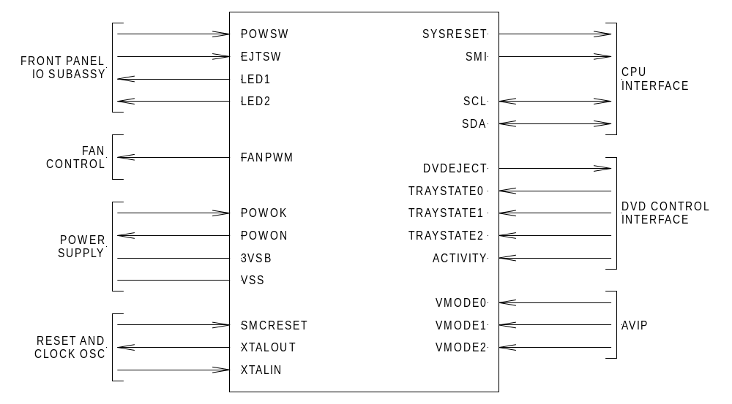
Figure 6 SMC I/O diagram
The SMC communicates with the CPU through the SMBus protocol.
The SMC micro-controller is specified as the Microchip PIC16LCR63T-10/SO. For detailed specifications of this chip, refer to the Microchip PIC16C63 data sheet.

Power Control and Temperature Monitoring
The SMC monitors the front-panel POWER switch and predictably and reliably controls the system power. The behavior of the POWER switch is to immediately toggle the power state of the system between the ON and OFF states, regardless of the status of the CPU. In the event of a CPU crash, the SMC will force the power OFF state without further intervention from the user.
The SMC will monitor the CPU die temperature and the internal ambient air temperature in one location of the chassis. Temperature sensing is implemented by use of a dedicated temperature sense IC. This IC measures the CPU die temperature by connecting to the on-chip temperature sense diode and can also measure the temperature of its own die by using an internal temperature sense diode.
Fan Control
The SMC will control the speed of the system fan in accordance with the measured die and air temperatures. If the system temperature exceeds a preset maximum threshold, the SMC will assert system RESET and maximize the fan speed.
Fan speed control is accomplished by pulse-width modulation as shown in the circuit below. The resistor values, transistor, and capacitor will be based on the detailed requirements of the fan.
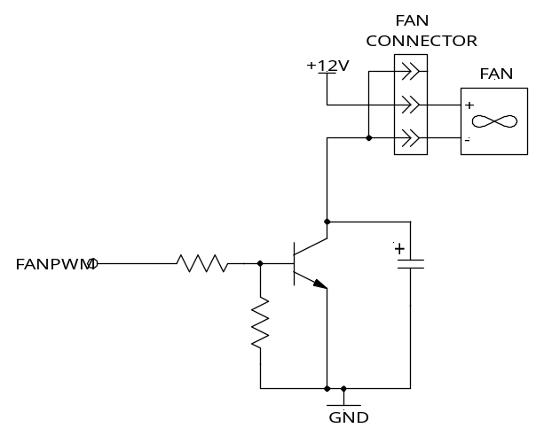
Figure 7. Fan speed control circuit
Front Panel I/O
The SMC is responsible for driving the front-panel indicator LEDs and monitoring the two user input buttons for activity. The front panel indicator is implemented as an array of red/green bicolor LEDs, capable of being illuminated RED, GREEN, or ORANGE (red and green simultaneously). Except for the default states of the LED defined by power ON and OFF, and OVERTEMP, the CPU may override the state of the indicator by issuing commands via the SMBus. The front panel user inputs consist of two buttons, POWER and EJECT. User input from these two buttons triggers responses by the SMC.
The schematic in figure 8 shows the interconnection of the front panel input/output (FPIO) components with the SMC. The small-value resistors in series with the DC power supplies provide protection from short circuit in case a wire insulation is abraded or exposed due to a drop shock event. The input circuits provide series impedance to protect the SMC from electrostatic discharge. The details of the transistor bias networks and LED series resistor values are to be determined pending final UI and industrial design.
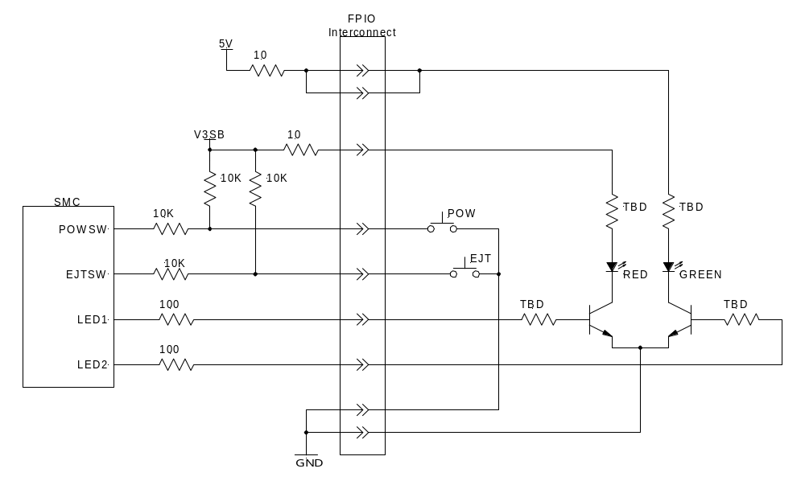
Figure 8 Front panel I/O schematic
AV Mode Detect
The SMC monitors the AVIP MODE inputs and reports the AV pack configuration via SMBus protocol. During operation, the SMC monitors the AVIP MODE pins for changes and reacts according to the manner described herein.
Upon system RESET, the AVIP mode is determined by sampling the state of the MODE 1/2/3 pins of the AVIP. If a valid AV pack is connected, that configuration is reported to the CPU. From that point onward, the SMC periodically samples the AVIP MODE pins to determine if the configuration has changed. The SMC will not recognize a transition to the NO PACK state as a change but will recognize changes between different configurations. This will allow the AV pack to be disconnected and reconnected without requiring the system to modify its output configuration.
If the SMC detects a new configuration, then it will notify the CPU via SMBus protocol.
System Clocking
The Xbox clocking system consists of several clocks. A block diagram of the system clocking requirements is shown in figure 9. In addition to the clock frequencies shown in the diagram, the CPU, GPU, MCPX, and TV encoder each contain phase-locked loops to synthesize the clocks used by internal logic.
System Clocking Architecture
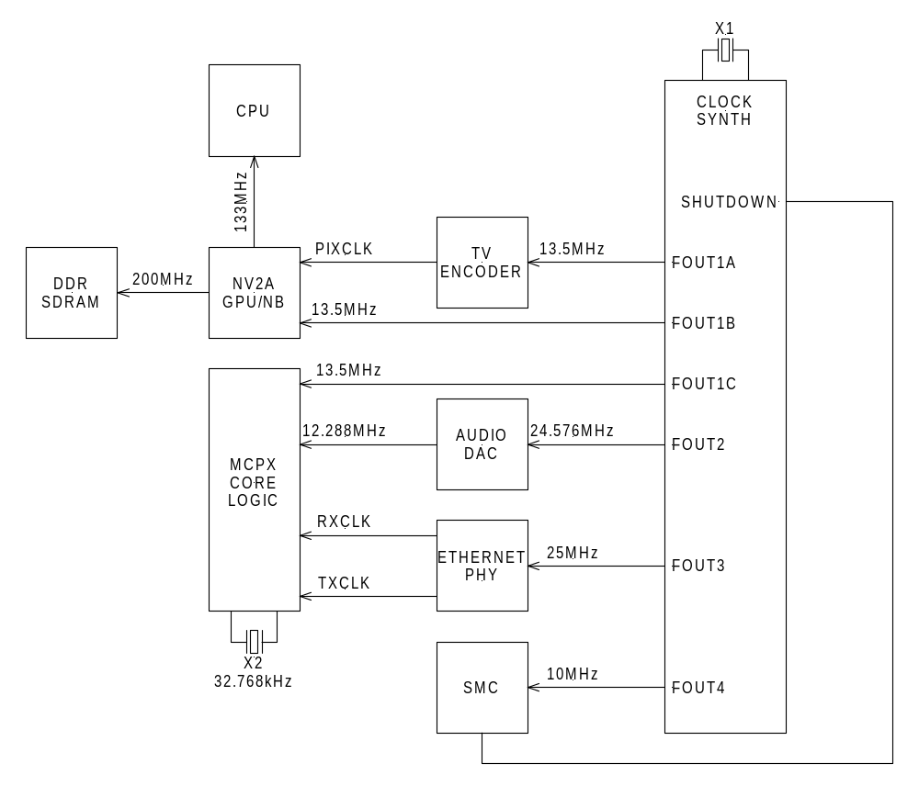
Figure 9 Clocking block diagram
- CPU clocking. The CPU contains a phase-locked loop to synthesize the internal core frequency as described in the CPU data sheet. The typical operating frequency for the CPU will be 733 MHz.
- Xbox GPU clocking. The GPU contains two phase-locked loops for internal clock generation. One PLL synthesizes the core clock (250-300 MHz), while a second synthesizes 800 MHz that is then divided down to generate the 133-MHz CPU FSB clock, the 200-MHz DDR memory clock, and the LDT interface to the MCPX. The PLLs are referenced to the 13.5-MHz input clock. The CRTC logic of the GPU is slaved to the PIXCLK generated by the TV encoder. This clock will vary in frequency depending on the video mode being output.
- DDR clocking. The DDR memory clock is synthesized by the internal PLL.
- MCPX clocking. The MCPX includes several PLLs to generate the internal clocks, including the USB clock (48 MHz), the ATA interface clock (66 MHz), the LDT interface clock (100 MHz and 200 MHz), and the legacy block clock (33MHz). The PLLs and the legacy block timers are referenced to the 13.5-MHz input clock. The MII interface is slaved to the 25-MHz clock input; this clock is transmitted from the PHY to the MCPX as RXCLK and TXCLK. The AC-Link and SP-DIF interfaces are referenced to the 12.288-MHz clock provided by the audio DAC. Lastly, the RTC block is clocked by an internal oscillator driven by an external 32.768-kHz crystal.
- TV encoder. The TV encoder inputs a 13.5-MHz reference clock from the clock synthesizer block. A buffered version of the 13.5-MHz clock is passed on to the MCPX clock to use as a reference for its internal PLLs. An internal PLL is used to generate the clocks required for video output and pixel data clocking. The TV encoder outputs the pixel clock to the Xbox GPU GPU. The TV encoder requires a 13.5-MHz clock with 25-ppm accuracy to meet requirements for NTSC and PAL color encoding.
- Audio DAC. The audio DAC inputs a 24.576-MHz reference clock from the clock synthesizer block. The reference clock is internally divided by two and output to the MCPX as a 12.288-MHz clock for audio, clocking both the AC-Link audio stream and the SP-DIF audio stream. The audio clock must exhibit zero long-term frequency error compared to the video clock.
- Ethernet PHY. The Ethernet PHY inputs a 25-MHz reference clock from the clock synthesizer block. The PHY drives two 25-MHz clocks into the MCPX. The Ethernet PHY requires an absolute frequency error of 100 ppm maximum.
- SMC. The SMC is clocked from a 10-MHz PLL from the clock synthesizer. Note that the SMC also provides a logic-level SHUTDOWN control to the clock generator chip. When asserted, all outputs except the SMC clock (FOUT1) are stuck at a low level. This allows full power down of all subsystems except the SMC.
Clock Generator
The clock synthesizer consists of a reference oscillator, driven by 27-MHz crystal, and two phase-locked loops. Three outputs, driven through a divide by 2 prescaler, are used to output the reference clock to three destinations: the TV encoder, MCPX, and Xbox GPU.
The PLLs generate clocks for the audio, Ethernet, and SMC. One PLL generates the audio clock, which will be derived from the following ratio: FOUT2 = 2048/1125 × 13.5 MHz. This ratio results in a zero ppm relative error between the audio and video clocks. A second PLL generates the 25-MHz and 10-MHz outputs by generating an intermediate frequency of 50MHz FOUT34 = 100/27 × 13.5 MHz, and dividing by 2 for FOUT3 and dividing by 5 for FOUT4.
The pin out table provides for independent power supply pins for the reference oscillator and output pins, for the audio clock PLL, and for the Ethernet/SMC PLL(s). These power pins are partitioned to minimize jitter on the FOUT1 pins.
The synthesizer also includes a SHUTDOWN pin which, when asserted, shuts down FOUT1, 2, and 3 but leaves the SMC clock (FOUT4) running. The shutdown outputs must stick in the logic “low” state. Note that the reference oscillator must continue to operate; only the output drivers are disabled.

- DVD Drive
The DVD drive will be used to load content and applications. The DVD drive must be capable of reading DVDs, audio CDs, and CD-ROMs. The DVD drive will not be capable of reading CD-recordable (CD-R) media.
The drive incorporates a tray loading mechanism that is operated electrically. The tray open and close control line is driven by the SMC in accordance with user input via the EJECT switch and the SMC state machine.
The DVD drive interfaces to the CPU through an ATA Interface shared with the hard disk. The DVD drive is configured as a slave device; the hard disk is configured as the master. The ATA interface will operate in UDMA-33 mode.
The following sections are provided for system-level design considerations only.
Media Compatibility
The drive is compatible with both 8-cm and 12-cm standard media. The drive will be capable of addressing the burst-cutting area of DVDs.
Nonstandard rectangular media based on the removal of material from a standard 8-cm disc is allowed, so long as the following restrictions are observed:
- The shape must be both statically and dynamically balanced about the center of the disc.
- The width and length of the disc must not fall below the dimensions shown in figure 10.
- The media format for this form factor may be CD-ROM or single-layer DVD.
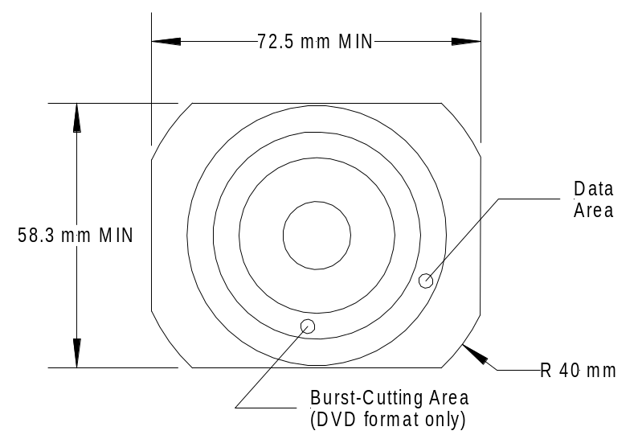
Figure 10 Rectangular optical disk media
Format Compatibility
- Single-layer, single- or dual-sided, 12-cm DVD-ROM (DVD-5 and DVD-10) manufactured in accordance with ECMA-267, 120-mm DVD-read-only disc.
- Dual-layer, single- or dual-sided, 12-cm DVD-ROM (DVD-9 and DVD-18) manufactured in accordance with ECMA-267, 120-mm DVD-read-only disc.
- Single-layer, single-sided, 8-cm DVD-ROM manufactured in accordance with ECMA-268, 80-mm DVD read-only disc.
- Dual-layer, single-sided, 8-cm DVD-ROM manufactured in accordance with ECMA-268, 80-mm DVD Read-Only Disc.
- CD-ROM XA (Yellow Book)
- CD-DA (Red Book)
DVD-RAM and CD-RW compatibility are specified here to support the development of applications only. DVD-RAM and CD-RW compatibility is not guaranteed on units sold in retail channels.
- Single-layer DVD-RAM of type to be determined by DVD drive manufacturer.
- CD-RW (read mode only)
Spindle Speed Control
The drive will operate at constant angular velocity (CAV) in both CD and DVD formats. CAV operation results in streaming speeds in the range of 2 to 4.8× for 12-cm DVD, and 6.4 to 16× for 12-cm CD. The spindle velocity will be selectable under software control, which may select one of three speeds:
- High speed. This speed corresponds to approximately 3,000 rpm, depending on the drive implementation, and results in the maximum DVD and CD read rates shown in the performance specification table.
- Medium speed. This speed corresponds to approximately 2,000 rpm. An application may select this speed to minimize acoustic noise, or the system software may select this speed automatically in response to a read error.
- Low speed. This speed corresponds to approximately 1,000 rpm and represents the slowest speed that the drive may be operated in. This speed will result in lowest power dissipation and lowest acoustic noise in the system, especially when reading rectangular media.
Performance Specifications
For the purposes of this specification, the following definitions apply:
- Access time. The time that elapses between an ATAPI command to read data from the disc and when the first data is transferred via the ATA interface. For practical purposes, this time includes the ATAPI command transit time, seek time, rotational latency, read/ECC time, and ATA data transit time.
- Average access time. The average time required to access data from the disc. This performance metric will be measured by the following profile: The seek will originate on any track on the disc to a track 1/3 of a stroke away, and the seeks will include an equal number of inner-to-outer and outer-to-inner seeks. The tool will accumulate a minimum of 200 seeks and compute the average by dividing the total amount of time required to perform the test by the number of seeks performed.
- Full stroke access time. The access time for a seek from the vicinity of the innermost track to the outermost track, or from the outermost track to the innermost track. This performance metric shall be measured by making subsequent inner-to-outer and outer-to-inner accesses, accumulating a minimum of 200 seeks, and dividing the total time elapsed by the number of seeks performed.
- Startup time. The time elapsed between the tray close and the first drive being ready to complete the first data transfer request. This metric will be measured using the standard test disc. The time will be measured from the point at which the tray reaches the closed position and will include the spindle startup time, the media detection and laser calibration time, and the read of the DVD-ROM root directly.
- Launch time. The time elapsed between the tray close and the first 64-MB launch file being transferred from the disc. This specification is provided for reference only, as an indication of the time required to launch a typical application from DVD. The actual time required to launch an application will vary depending on the physical location of the launch file, the exact size of the file, and the quality of the DVD media.
This metric will be measured using the standard test disc, which contains a 64-MB file located near the vicinity of the outermost track on the disc. The time will be measured from the point at which the tray reaches the closed position and will include the startup time (as defined above), the time required to seek to the launch file, and the transfer of the complete 64-MB launch file.
- Sustained data rate. The rate at which data may be read continuously from the disc and transferred via the ATA interface, averaged over a large data file located on physically contiguous tracks. The time will be measured between the first ATAPI command to read data following a seek command and the final data being transferred. The rate will be computed by dividing the size of the data file by the time elapsed.
Table 4 DVD data access performance specifications
Parameter | Min | Typical | Max | Unit
Reference streaming speed  1x DVD  1x CD-ROM Mode 1  1x CD-ROM Mode 2  1x CD-DA |  | 11.08  1.23  1.40  1.41 |  | Mbps
CAV rotational velocity  Single layer DVD  Dual layer DVD  All CD formats | 1148  1148  1148 |  | 2870  3160  3160 | rpm
Relative DVD streaming speed (read only, CAV)  12-cm media  8-cm media  Rectangular media | 2x  2x  2x |  | 5x  3.3x
Sustained DVD data rate  12-cm DVD media  8-cm DVD media  Rectangular DVD media | 22.16  22.16  22.16 |  | 55.40  36.56  TBD | Mbps
Relative CD streaming speed (read only, CAV)  12-cm media  8-cm media  Rectangular media | 6.4x  6.4x  6.4x |  | 16x  9x
Sustained CD data rate  12-cm CD-ROM Mode 1  12-cm CD-ROM Mode 2  12-cm CD-DA  8-cm CD-ROM Mode 1  8-cm CD-ROM Mode 2  8-cm CD-DA  Rectangular media | 7.87  8.96  9.02  7.87  8.96  9.02  TBD |  | 19.68  22.40  22.56  11.07  12.60  12.69 | Mbps
Average access time (1/3 stroke, at max angular velocity)  CD  DVD-5  DVD-9 |  | 100  130  130 |  | ms
Full-stroke access time (1/3 stroke, at max angular velocity)  CD  DVD-5  DVD-9 |  | 300  300  300 |  | ms

The access and streaming data rates specified here represent average performance as defined earlier in this section. Actual access time for any particular access may be faster or slower than the specified average depending on the location of the head, the target location requested, the condition of the media, and any external vibration or shock input.
Throughout the life of the Xbox game system, the DVD drive may undergo design changes for cost reduction. These design changes may result in different performance for particular accesses, but the same average performance will be met.
Software developers should avoid depending on the timing of the DVD access in their applications.
Table 5 DVD system timing specifications
Parameter | Min | Typical | Max | Unit
Startup time (this parameter is to be minimized)  DVD-5  DVD-9 |  | 8  8 | TBD  TBD | sec
Launch time (this specification is provided for reference)  DVD-5 or DVD-9 |  | 18 |  | sec
Spin-down time |  |  | 8 | sec
Time to restart from idle |  |  | 5 | sec
Tray open/close time |  |  | 4 | sec
Laser auto-shutdown time |  | 15 |  | sec
Laser recovery time (recovery from shut down) |  |  | 700 | ms
Read error timeout |  | 2 |  | sec

Electrical Specifications
The electrical interface will consist of two ports: an ANSI ATAPI compatible interface port and an auxiliary power and loader control interface.

The ATAPI interface will operate over an ATA-33 physical interface. The ATA interface connector will be a 40-pin header with 2.54-mm center-to-center pin spacing, conforming to ANSI SFF 8059.
The ATA interface uses 3.3-V signaling. The interface must support DMA multiword modes 0 to 3 and DMA-33. PIO mode 0 is also required.
The DVD drive will be configured as a slave device on the ATA port. The drive will support standard ATAPI commands as described in the Software Requirements section of this document, as well as the specified special-purpose commands.
Power and Control Interface
The loader control/status interface and 12-V DC power will be implemented on a secondary multi-pin connector.
Software Requirements
ATA Commands for ATAPI DVD-ROM Devices
- 0xA1 ATAPI Identify Device
- 0xA0 ATAPI Packet Command
- 0x08 ATAPI Soft Reset
- 0xE5 Check Power Mode
- 0x90 Execute Device Diagnostics
- 0xEC Identify Device
- 0xE1 Idle Immediate
- 0x00 NOP
- 0xEF Set Features
- 0xE6 Sleep
- 0xE0 Standby Immediate
ATAPI Packet Commands
- 0x4A Get Event/Status Notification
- 0x12 Inquiry
- 0xBD Mechanism Status
- 0x55 Mode Select(10)
- 0x5A Mode Sense(10)
- 0x1E Prevent/Allow Media Removal
- 0x28 Read(10)
- 0xA8 Read(12)
- 0xBE Read CD
- 0x25 Read Capacity
- 0xB9 Read CD MSF
- 0xAD Read DVD Structure
- 0x43 Read TOC/PMA/ATIP
- 0xA4 Report Key
- 0x03 Request Sense
- 0x2B Seek(10)
- 0xA3 Send Key
- 0x00 Test Unit Ready
Xbox-Specific ATAPI Commands
- 0x Set Speed
Hard Disk
The hard disk is specified for lowest cost with suitable reliability for the console application. The expectation is that the lowest-cost configuration for the hard disk is a single-platter, single head in a standard 3.5-inch form factor. The capacity of the hard disk is optimized for cost and is not required to increase over time, so the capacity specified represents the minimum capacity desired. The final revision of this document will specify the actual capacity of the hard disk.
The minimum performance requirements required for the drive are as follows:

- Form factor—standard 3.5-inch form factor per ANSI specification SFF-8300.
- Capacity—the capacity will be representative of the state of the art for a single platter and single head disk drive in the first year of production. The capacity of the drive will be no less than 8 GB. The final revision of this specification will specify the minimum drive capacity.
- Electrical interface—the electrical interface will, at a minimum, conform to the ATA-2 interface standard (ANSI NCITS 317-1998). The interface connector will be a 40-pin ATA header with 100-mil center-to-center pin spacing per ANSI SFF-8059.
- Command set—the interface must support DMA multiword modes 0 to 3, DMA-33. PIO modes 0 to 2 may be supported but are not required. The drive will also support SMART self-test diagnostic features.
Table 6 Performance requirements
Parameter | Min | Typical | Max | Unit
Startup time  from Power ON to Drive Ready  from Standby to Drive Ready |  | 8  6 | 12  12 | sec
Spin-down time  from Standby command  from Power OFF |  | 6  12 | 15  30 | sec
Random seek/read time |  | 8 | 15 | ms
Random seek/write time |  | 12 | 16 | ms
Full-stroke seek time |  | 18 | 30 | ms
Track to track seek time |  | 2 |  | ms
Data transfer rate, sustained | 12 |  |  | MB/s
Acoustic sound power L_{W} (A)  measured in anechoic chamber with background noise level at least 10 dB below the expected measured level |  | 3.1 | 3.7 | bel
The access times specified here represent average performance as defined earlier in this section. Actual access time for any particular access may be faster or slower than the specified average depending on the location of the head, the target location requested, the condition of the media, and any external vibration or shock input.
Throughout the life of the Xbox productgame system, the HDD hard disk may undergo design changes for cost reduction. These design changes may result in different performance for particular accesses, but the same average performance will be met or exceeded. The speed of the drive will most likely increase in future years.
Software developers should avoid depending on the timing of the hard disk access in their applications.
Network Interface
The network interface port is compatible with IEEE 802.3 operating at 10 Mb/sec and 100 Mb/sec. The physical interface to Category 5 (100 Mb/sec) and Category 3 (10 Mb/sec) operation is implemented with a single-chip Ethernet transceiver, an isolation transformer, and associated passive components.
Ethernet PHY
The requirements for the Ethernet transceiver are as follows:
- 10 Mb/sec (IEEE 802.3) and 100 Mb/sec (IEEE 802.3u) with auto-negotiation
- 3.3 V supply voltage and interface
- Automatic polarity detection and correction of RX channel
- Full-duplex operation
- Media Independent Interface (MII)
The Ethernet transceiver selected for the Xbox game system is the Level One LXT972LC.
The LXT972 is an IEEE compliant Fast Ethernet PHY Transceiver that directly supports both 100BASE-TX and 10BASE-T applications. It provides an MII for easy attachment to 10/100 media access controllers.
The LXT972 supports full-duplex operation at 10 Mb/sec and 100 Mb/sec. Its operating condition can be set using auto-negotiation, parallel detection, or manual control.
The LXT972 is fabricated with an advanced CMOS.
The features of the LXT972 are as follows:
- 3.3-V operation
- Low power consumption (300 mW typical)
- 10BASE-T and 100BASE-TX using a single RJ-45 connection
- Supports auto-negotiation and parallel detection
- MII interface with extended register capability
- Robust baseline wander correction performance
- Standard CSMA/CD or full-duplex operation
- Configurable via MDIO serial port or hardware control pins
- Integrated, programmable LED drivers
- 64-pin low-profile quad flat package (LQFP)
A block diagram for the PHY is shown in figure 11.

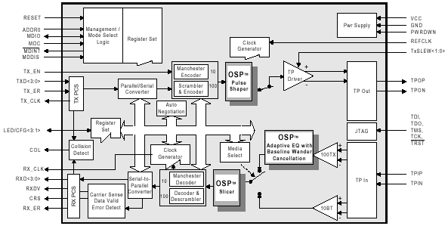
Figure 11 Ethernet PHY block diagram
Network Connector
The connector is mounted at a right angle to the PCBA. The RJ-45 connector is presented in a tab-up orientation (tab away from the PCB side). Two LEDs, one on either side, are integrated into the connector body. The green LED, on the left of the tab release, will be illuminated when a network connection is established and will blink when there is activity on the line. The yellow LED, on the right of the tab release, will be illuminated if the connection is established at 100 Mb/sec and will not be illuminated if connected at 10 Mb/sec.
Table 7 specifies the pin out of the RJ-45 network connector.

Table 7 Network connector pin out
Pin | Signal Name | Direction | Comment
1 | TPOP | OUT | Transmitter, positive phase
2 | TPON | OUT | Transmitter, negative phase
3 | TPIP | IN | Receiver, positive phase
4 | Termination | Passive
5 | Termination | Passive
6 | TPIN | IN | Receiver, negative phase
7 | Termination | Passive
8 | Termination | Passive

Audio Video Interface Port (AVIP)
The Xbox game system provides all audio and video signals on a single multi-pin AV connector referred to throughout this document as the AVIP. The AVIP provides all four video output signals, status signal for SCART, stereo line-level audio outputs, SP-DIF digital audio output, and the VMODE inputs.
An AV pack is connected to the AVIP to break out the signals for interconnection to a television and or audio system. By asserting the states of the VMODE control inputs, an AV pack identifies what type of television signals should be generated and whether the audio output should be stereo or mono.
Mechanical Connector Characteristics
The AVIP connector consists of 24 pins total, organized as two rows of 12 conductors each, with odd numbered pins on one side of the connector and even numbered pins on the other. The pins carry power, video, audio, and some logic-level input and output signals. The DCOUT and DCRETURN pins are located at the far ends of the connector. The mechanical design of the connector is such that the DCOUT and DCRETURN contacts are guaranteed to make contact before any signal pin.
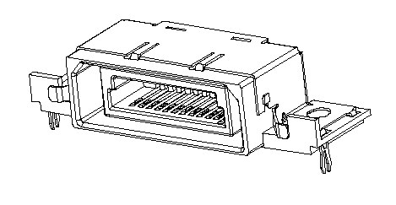
Figure 12. AVIP mechanical sketch output
Pin | Signal Name | Direction | Comment
1 | DCOUT | OUT | The output of this pin provides a current-limited DC power supply for active AV pack circuitry.
2 | LINE OUT (R) | OUT | This pin outputs line-level right channel linear audio.
3 | LINE OUT (L) | OUT | This pin outputs line-level left channel linear audio.
4 | GND | - | This ground is provided for connection to the right channel audio cable shield.
5 | GND | - | This ground is provided for connection to the left channel audio cable shield.
6 | SPDIF | OUT | This pin is the SP-DIF logic-level output.
7 | HSYNC | OUT | Horizontal sync signal used for VGA output mode
8 | VSYNC | OUT | Vertical sync signal used for VGA output mode
9 | MODE1 | IN | Video output mode select pin 1
10 | GND | - | This pin provides a convenient grounding point for the MODE1 input if needed.
11 | MODE2 | IN | Video output mode select pin 2
12 | GND | - | This pin provides a convenient grounding point for the MODE2 inputs if needed.
13 | MODE3 | IN | Video output mode select pin 3
14 | GND | - | This pin provides a convenient grounding point for the MODE3 inputs if needed.
15 | STATUS | OUT | SCART status pin
16 | GND | - | Ground connection for pin 18 (Pb)
17 | GND | - | Ground connection for pin 19 (C/Pr)
18 | Pb  B | OUT | This pin outputs the Pb component signal in HDTV mode, and the BLUE component signal in RGB SCART mode.
19 | C  Pr  R | OUT | This pin outputs the Chroma signal in SDTV mode, and the Pr component signal in HDTV mode, and the RED component signal in RGB SCART mode.
20 | GND | - | Ground connection for pin 22 (Y)
21 | GND | - | Ground connection for pin 23 (CVBS)
22 | Y  G | OUT | This pin outputs the luma signal in both SDTV and HDTV modes, and the GREEN component signal in RGB SCART mode.
23 | CVBS | OUT | This pin is dedicated to the composite video out (CVBS) in SDTV mode. In HDTV mode, this pin is not used.
24 | DCRETURN | - | This pin is specifically designated to carry the DC return current.
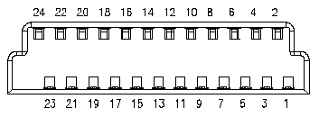
Figure 13 AVIP connector pin out
DC Power Output
The AVIP DCOUT pin supplies 5-V power to the AV pack if needed. The output of the AVIP is protected against short circuit internally by a positive temperature coefficient thermistor. The design of the short-circuit protection circuit will guarantee the DC output voltage range specified over the entire load current range and over the entire operating temperature range.
Table 8 AVIP DCOUT Output Characteristics
Parameter | Min | Typical | Max | Unit
DCOUT Voltage | 4.70 | 5.00 | 5.25 | V
DCOUT Current |  |  | 250 | mA

Mode Selection Inputs
The AVIP supports several output configurations. The MODE inputs to the AVIP are provided to identify the type of signals expected by the AV pack. The output mode is identified by jumper wires between the mode select pins (MODE1, MODE2, and MODE3) and GND pins on the AVIP connector as shown in table 9.
The state of these inputs is continuously monitored by the SMC and communicated to the Xbox system software. Changes in the state trigger notification to the system software that the AV mode has changed.
The state of these pins does not directly control the video or audio mode; the system software configures the CRT controller of the GPU and the TV encoder through software. It is possible to configure these independently of the MODE state pins, as may be required for test purposes.
Table 9 Video mode definitions
AVIP Mode Input (Pin) |  |  | Video Mode | AVIP Video Output (Pin)
M[0] (9) | M[1] (11) | M[2] (13) | Video Mode | (23) | (22) | (19) | (18)
OPEN | OPEN | OPEN | No AV pack present | - | - | - | -
OPEN | OPEN | GND | 525/60 RFU mode (NTSC, mono audio) | CVBS_{NTSC} | Y_{NTSC} | C_{NTSC} | -
OPEN | GND | OPEN | 625/50 RFU mode (PAL/SECAM, with mono audio) | CVBS_{PAL} | Y_{PAL} | C_{PAL} | -
GND | OPEN | OPEN | 525/60 SDTV mode  (NTSC) | CVBS_{NTSC} | Y_{NTSC} | C_{NTSC} | -
GND | OPEN | GND | VGA | - | G | R | B
GND | GND | OPEN | 625/50 SDTV mode  (PAL-I) | CVBS_{PAL} | - | - | -
GND | GND | GND | 625/50 SDTV mode  (PAL-I) SCART | CVBS_{PAL}  Y_{PAL}  - | -  -  G | -  C_{PAL}  R | -  -  B

Digital Audio Output
The AVIP provides a logic-level SP-DIF signal for digital audio interfaces. The SP-DIF output is a 3.3-V logic swing and must be electrically or optically conditioned to implement a standard IEC-60958 interface. This function is implemented in the enhanced AV packs by use of an optical transmitter module, such as Toshiba TOTX-178A.
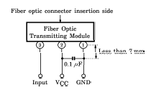
Figure 14 SP-DIF optical transmitter module
Analog Audio Output
The analog audio output is a circuit comprising an audio DAC, a filter/amplifier, and a coupling network. Figure 15 shows the interconnection of the various components. The MCPX provides the digital audio stream via the AC-Link interface to the audio DAC. The audio DAC is implemented as a simplified AC-97 codec that features only stereo output, without mixer or volume control features.
The clock source for the system is the 24.576-MHz output of the clock generator chip. The DAC provides clocking for the AC-Link interface. The SMC drives a clamp control line that, when used in conjunction with the power supply POWON and the AC-Link nRESET signal, provides a means of powering up and down the system with minimal “pop” being generated by the audio circuits.
The filter/amplifier is a simple operational amplifier stage that provides a second-order low pass response and additional voltage gain to meet the output level requirements. The coupling network provides DC blocking and electrostatic discharge (ESD) protection for the active circuitry.
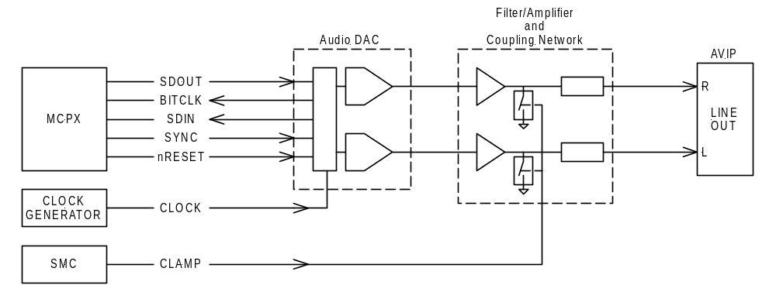
Figure 15 Analog audio block diagram
Performance Requirements
The analog audio output will be designed to IEC-61938 specifications for analog audio interface impedances and levels. In addition, the system will be designed to minimize “pop” when power is cycled. The performance requirements of the analog audio path are summarized in table 10.
Table 10 Analog audio output performance specifications
Parameter | Min | Typical | Max | Unit
Full-scale output voltage (1-kHz tone at 0 dBFS)  (note 1) |  |  | 2.0 | V_{RMS}
Inter-channel relative phase mismatch (notes 2, 3) |  |  | 5 | °
Inter-channel output level mismatch (note 3) |  |  | 0.5 | dB
Dynamic range (note 4) | 85 |  |  | dB
Pass band frequency | 20 |  | 20k | Hz
Pass band frequency response (note 5) | -1.0 |  | +0.5 | dB
Frequency response (-3dB) |  | 22 |  | kHz
Total harmonic distortion and noise (THD+N) (note 6) |  |  | 0.1 | %
Channel separation (note 6) | 80 |  |  | dB
Signal to noise ratio (SNR) | 85 |  |  | dB
Output impedance (note 7) | 20 | TBD | 2200 | Ω

Note 1 Measured while outputting a 1-kHz tone at 0 dBFS.

Note 2 All outputs must maintain absolute polarity and the same phase relationship between channels as the original input signals as specified.
Note 3 Measured with –20 dBFS signal output on both channels
Note 4 Measured relative to a 0 dBFS signal, using CCIR-2k weighting and an average responding meter
Note 5 Measured relative to a –10 dBFS input signal over the entire pass band frequency range
Note 6 Measured relative to a 0 dBFS signal
Note 7 Line outputs to be capacitively coupled
Audio DAC Requirements
The audio DAC converts the AC-Link audio stream to an analog signal. The DAC is implemented as a simplified stereo AC-97 codec, with the mixer, volume controls, analog inputs, and analog to digital conversion functions eliminated. The AC-Link interface is 3.3-V logic and is compliant with AC-97 v1.03. The clock (24.576 MHz) is provided by the system clock generator.
Filter Network Requirements
The audio filter and coupling network perform additional analog signal conditioning to meet the remaining audio output requirements, which are as follows:
- Filtering: The filter provides attenuation of out-of-band noise generated by the sampling aliases and high-frequency noise coupled from the high-speed digital electronics in the rest of the system.
- Amplification: The DAC output is limited to 1 V_{RMS} peak output. The filter network provides a gain of 2 so that the output is capable of 2 V_{RMS} peak output.
- DC elimination: The DAC output and filter output are DC biased because of the use of unipolar power supplies. The coupling capacitor provides blocking of the DC component.
- ESD isolation: The series resistance and associated capacitance provide protection from ESD events coupled directly to the audio output pin.
- Power on transient suppression: The FET switch provides a means of controlling the discharge of the DC voltage across the coupling capacitor, preventing the output from emitting a “pop” during power up/down events. The system will allow 200 ms from RESET for the anti-pop circuits to stabilize before the first audio signals are generated.
Video Outputs
The analog video outputs are driven by a television encoder, which is driven by the digital video interface of the GPU. The television encoder converts the digital video to composite NTSC/PAL, component S-video, and component RGB television signals.
The TV encoder has four DAC outputs. These four outputs are multiplexed among the three main modes of operation, SDTV, and SCART. In SDTV mode, the DACs must output CVBS, Y, and C to support composite and S-video outputs. In SCART mode, the DACs must output CVBS and RGB component signals.

The sections that follow describe the filter arrangements for each of the modes in detail.
SDTV Mode
The SDTV mode includes two video outputs: composite (CVBS) and S-video (Y/C). The CVBS, Y, and C signals are output simultaneously on individual pins of the AVIP connector, each capable of driving a single 75-ohm back-terminated transmission line. This mode applies to the standard NTSC, standard PAL, and standard SCART AV packs. The enhanced SCART AV pack, which supports component RGB output, is described in the next section.
DAC D of the TV encoder is dedicated to the CVBS output, allowing its accompanying filter to be implemented directly on the motherboard. A standard NTSC, PAL, or SCART AV pack supports only composite video output, so this can be implemented with a simple cable.
Enhanced AV packs support S-video, so they require Y and C outputs in addition to the CVBS output.
Figure 16 shows how the filters are arranged in the Xbox game system and AV pack to implement the SDTV mode.
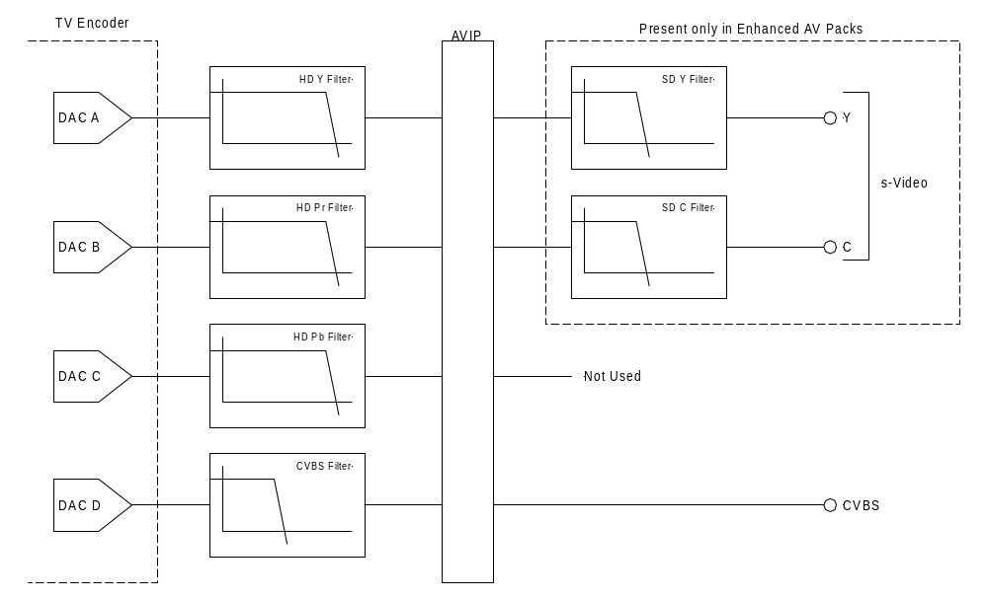
Figure 16 Video filter arrangement, SDTV mode

Enhanced SCART Mode
The SCART interface provides four video signals that can be configured to be composite video and component RGB (CVBS + RGB), or S-video (Y/C). The Xbox system software can select either mode when the enhanced SCART AV pack is connected to the Xbox game system.
In the CVBS + RGB configuration, the CVBS, R, G, and B signals are output simultaneously on individual pins of the AVIP connector, each capable of driving a single 75-ohm back-terminated transmission line.
In the Y/C mode, the Y and C signals are driven on the appropriate pins. The two remaining pins that would normally carry B and G signals are driven with the Y waveform.
In addition to the video outputs, an additional pin drives the aspect ratio selection pin on the SCART connector. This pin is set to one of three voltage levels to indicate the format of the output video signals in SCART mode. The details of this output circuit are described in a later section.
DAC A is dedicated to the CVBS output, allowing its accompanying filter to be implemented directly on the motherboard. The R, G, and B outputs are cascaded filters identical to that described in the SDTV Mode section. For filter characteristics, refer to that section.
Figure 17 shows how the filters are arranged in the Xbox game system and attached AV pack to implement the enhanced SCART mode.
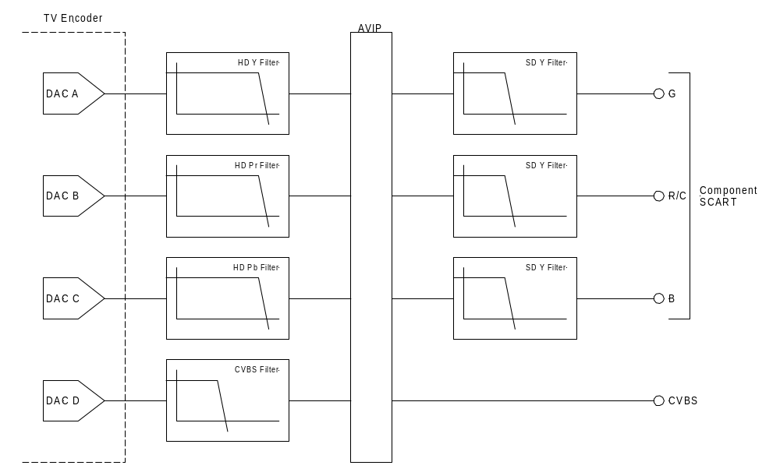
Figure 17 Video filter arrangement, component SCART mode

VGA Mode
The AVIP supports a VGA mode interface for development purposes only. Compatibility with all VESA monitors is not guaranteed. The VGA implementation is described here for reference only.
The VGA mode of the AVIP provides component RGB video signals and HSYNC and V-SYNC signals only. The implementation of VGA in the Xbox game system does not provide DDC serial communication for monitor configuration. Electrically, the AVIP uses the RGB outputs as described in the Enhanced SCART Mode section, with the addition of the HSYNC and VSYNC signals as shown in figure 19.
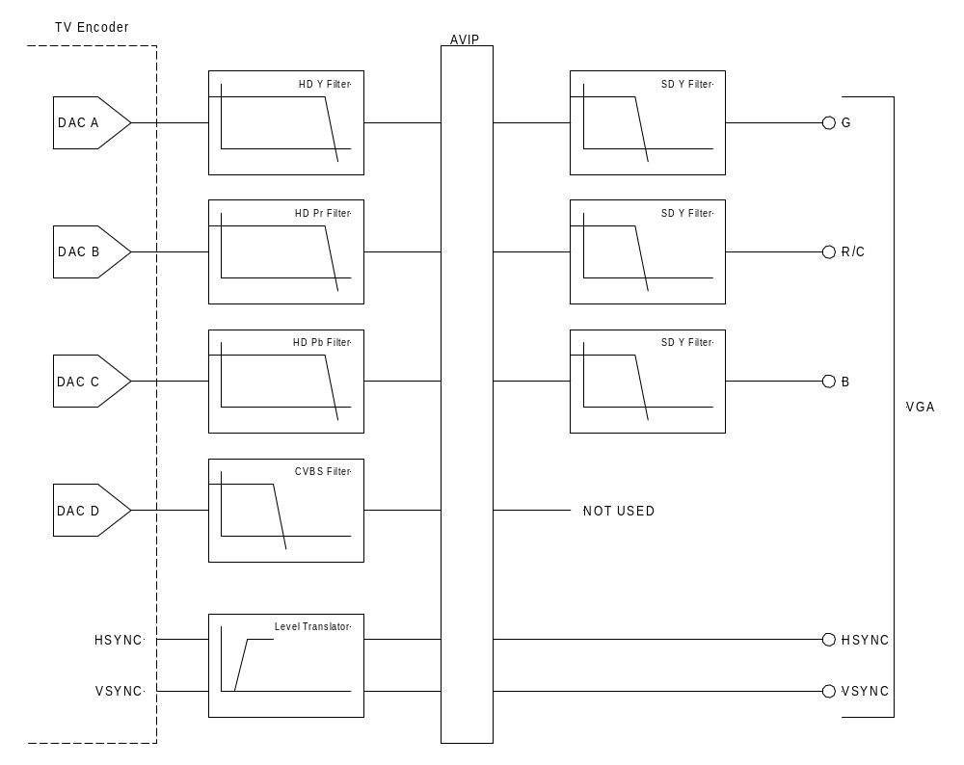
Figure 19 Video filter arrangement, component SCART mode
For filter characteristics, see the Enhanced SCART Mode section. The level translator shown for HSYNC and VSYNC signals is provided to protect the TV encoder and GPU from ESD, and to provide logic level translation from the low-voltage interface to TTL signaling levels required for VGA.
SCART Status Output
The AVIP port provides an output used to drive the SCART FUNCTION SWITCHING (pin 8 of the 21-pin Type II connector). The output levels expected at this pin are defined in EN-50049-1 as shown in table 11.
Table 11 SCART aspect ratio control signal specifications
Parameter | Min | Typical | Max | Unit
Level 0 (internal television broadcast reproduction) | 0.0 |  | 2.0 | V
Level 1A (reproduction of source with 16:9 aspect ratio) | 4.5 |  | 7.0 | V
Level 1B (peritelevision reproduction) | 9.5 |  | 12 | V
Output resistance | 300 |  | 1000 | Ω
Rise time from Level 0 to Level 1B  C_{LOAD} = 2nF, R_{LOAD} = 10kΩ |  |  | 5 | ms

Functional Requirements
- Output characteristics will be as defined in table 11.
- The output will default to the Level 0 output level when power is off or AC mains are disconnected. When Level 0 is asserted, the monitor device ignores the input video signals. If the monitor device is a television, it will automatically select its internal tuner as a video source.
- The Xbox game system will programmatically select to output either the Level 0 or Level 1A, or Level 1B output conditions.
- Output Level 1B will be asserted when the Xbox game system is outputting video in 4:3 aspect ratio.
- Output Level 1A will be asserted when the Xbox game system is outputting video in 16:9 aspect ratio.
Electrical Implementation
The STATUS output is controlled by the state of two GPIO lines driven digitally to one of three legal states. The three legal states correspond to Level 0, Level 1A, and Level 1B according to the states of the control inputs. The control inputs are driven at 3.3-V levels, according to the following table:
Table 12 Status control state diagram
LVLCNT0 | LVLCNT1 | STATUS
LO | LO | Level 1B
HI | LO | Level 1A
HI | HI | Level 0
LO | HI | Undefined

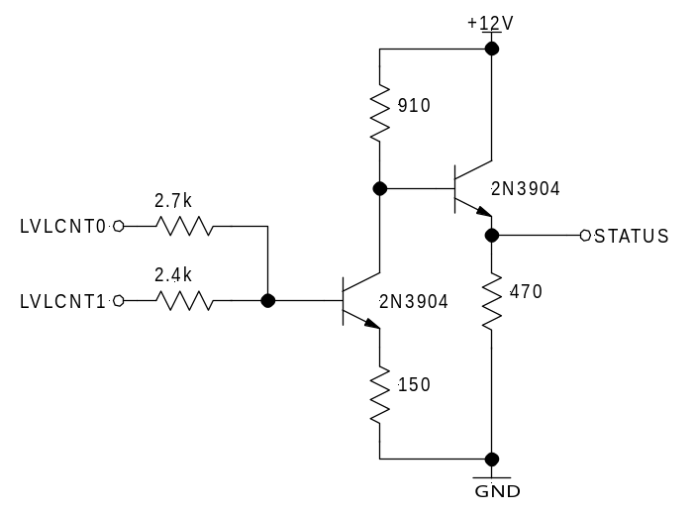
Figure 20 SCART status output circuit
Controller Interface Port
The controller interface port provides a means of connecting peripheral devices to the Xbox game system. The port is designed primarily for game controller–type devices but may also be used for any other peripherals that are to be connected to the Xbox game system.
The port provides DC power, a bidirectional digital communication bus, and a video synchronization signal to support peripherals that use CRT timing (such as light guns). Each aspect of the controller port is discussed in the following sections.
Mechanical Specification
The mechanical connector used for the controller interface is a custom design for the Xbox game system but is based on the electrical specification of the Type A USB connector specified in the universal serial bus specification. A fifth conductor is added to output the video sync signal.
Although the electrical specification is based on the Type A USB connector, the mechanical design is very different. The Xbox controller port connector is designed to be more robust in terms of insertion cycles, extraction force, and side pull durability.
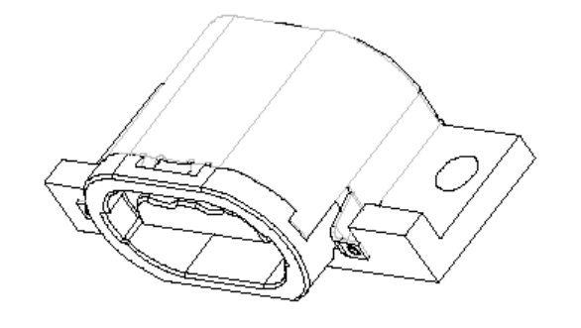
Figure 21 Controller port mechanical sketch
Table 13 Controller port pin out
Pin | Signal Name | Direction | Comment | 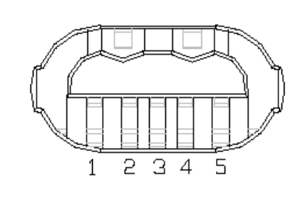
1 | V_{BUS} | POWER | 5 V @ 500 mA max peripheral power
2 | D+ | IO | USB differential signaling pair
3 | D- | IO | USB differential signaling pair
4 | CSYNC | OUT | Composite sync output
5 | GND | POWER | DC and signal return

Digital Communication
The data interface is differentially signaled as per the USB specification but supports only the full speed (12Mbits/sec) signaling protocol. The driver in Xbox system software does not support all the USB-class devices, thus this port is not truly a USB version 1.1 port; it uses only the full-speed USB physical layer protocol.
The MCPX provides the differential transceivers connected to the four main controller ports.
The motherboard design of the Xbox game system supports a fifth controller port for development purposes only. This port is also driven by the MCPX, but the port is not populated in production units of the Xbox game system.
Video Sync Signal
The Nvidia GPU outputs a composite sync signal to each of the controller ports. This signal is provided to support the implementation of controllers that need to have a timing reference to the CRT output. An example of such a controller is a light gun that provides X,Y pointing input to the Xbox game system based on the location of the screen that it is pointed to.
The sync waveform is to be determined pending implementation in the Nvidia GPU logic. The signal may or may not resemble a standard composite sync waveform; however, a downstream device will be capable of determining both vertical and horizontal timing based on this signal.
Power Supply
This section describes the assumptions and design guidelines related to the Xbox power supply. The power supply is implemented as three functional blocks. A system power supply unit (PSU) provides the bulk power conversion from the AC line input to regulated DC voltages. Local regulation on the motherboard converts the PSU outputs for the critical core voltage supplies required by the CPU, GPU, and DDR memory. Other local regulators provide low-noise analog power supplies for the audio and video sections. Lastly, a battery-powered supply provides power to maintain the real time clock and NVRAM contents when line power is unavailable.
The power supply shutdown is controlled by the SMC, as described in the System Management Controller section of this document. The system PSU must provide a low-current supply voltage to the SMC at all times; this output is referred to as 3VSB in the block diagram, figure 22. This supply is active at all times, so long as the supply is connected to the AC mains to provide power for the SMC and to charge the RTC/NVRAM backup battery.
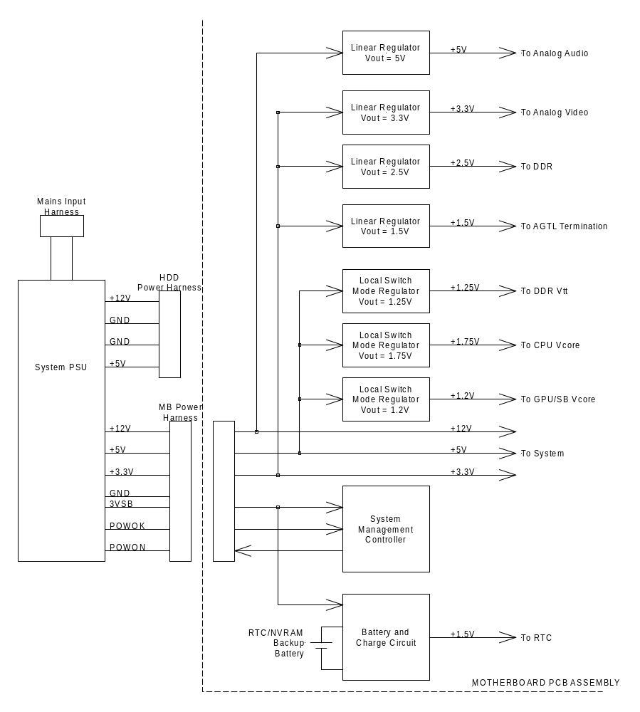
Figure 22 Power supply block diagram
Accessories
Game Controller
The game controller interfaces to the Xbox game system via a custom port. The connector used for the controller port will be of a special design proprietary to the Xbox game system to meet the special needs of the console environment. The port will be electrically compatible with USB version 1.1 specifications but may have special protocol requirements that deviate from the original USB specification.
AV Packs
The Xbox game system is connected to television and audio equipment by use of intermediate cable sets referred to as AV packs. The AV packs break out the video and audio signals to connectors suited to interface to various types of AV equipment. In addition to providing connector adaptation, the AV packs provide information to the Xbox game system that enables the Xbox game system to tailor the output signals as necessary.
For example, if the standard NTSC AV pack is connected, the Xbox game system automatically configures its output for composite NTSC output and stereo analog audio output. If the NTSC RFU AV pack is connected, the Xbox game system configures its output for NTSC composite and S-video, and mono audio output.
The AV packs are summarized in the following sections.
Standard NTSC AV Pack
The standard AV pack connects to the AV interface port of the Xbox console and provides composite video out and line-level stereo audio out. The video and audio outputs are output on standard consumer video phono-type plugs.
- Composite video out—one consumer video phono-type cable connector. The cable must be shielded and have nominal impedance of 75 ohms. The shield will provide a minimum of 85 percent coverage, such as UL Type 1354 (26 or 28 AWG) or equivalent.
- Analog audio out (left)—one consumer audio phono-type connector. Cable will be shielded (spiral or braided), such as UL type 1185 (26 AWG) or equivalent.
- Analog audio out (right)—one consumer audio phono-type connector. Cable will be shielded (spiral or braided), such as UL type 1185 (26 AWG) or equivalent.
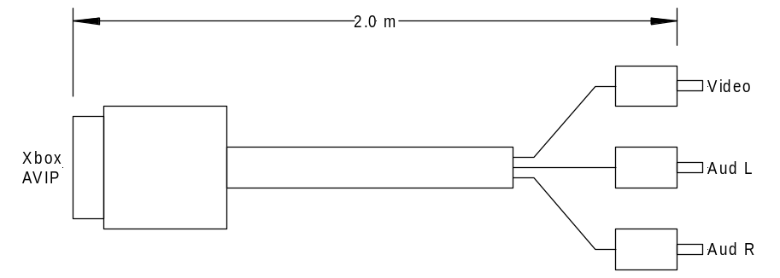
Figure 23 Standard AV pack
Standard PAL AV Pack
The standard PAL AV pack connects to the AV interface port of the Xbox console and provides composite video out and line-level stereo audio out. The video and audio are output on standard consumer video phono-type plugs.
- Composite video out—one consumer video phono-type cable connector. The cable must be shielded and have nominal impedance of 75 ohms. The shield will provide a minimum of 85 percent coverage, such as UL Type 1354 (26 or 28 AWG) or equivalent.
- Analog audio out (left)—one consumer audio phono-type connector. Cable will be shielded (spiral or braided), such as UL type 1185 (26 AWG) or equivalent.
- Analog audio out (right)—one consumer audio phono-type connector. Cable will be shielded (spiral or braided), such as UL type 1185 (26 AWG) or equivalent.
The layout of the standard PAL AV pack is identical to that of the standard NTSC AV pack shown in figure 23. Note that the two differ only in the MODE jumpers that identify the pack to the Xbox game system.
SCART Adapter
The SCART adapter is used to adapt the standard PAL AV pack to televisions equipped with a SCART-style connector. In this configuration, the SCART interface provides only composite video output and stereo audio.
The adapter consists of a SCART connector and three phono-style input jacks for composite video, left audio, and right audio as output from the standard PAL AV pack.
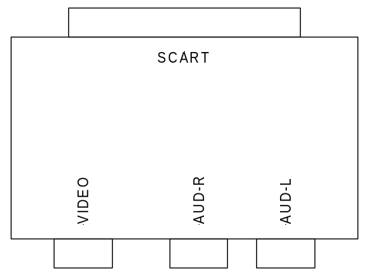
Figure 24 SCART adapter
Standard SCART AV Pack
The standard SCART AV pack for the European market provides a means of attaching the Xbox game system to a television monitor with SCART input. The Xbox SCART connector conforms to the electrical interface and impedances described in EN 50049-1 and is upwardly compatible with the chain interconnection system described in EN 50157-2-1. The Xbox SCART plug is designed to plug into a Type I SCART port on a television monitor or other audio/video equipment.
The standard SCART AV pack supports only the PAL TV mode and provides composite video as the only video signal option. S-video and RGB component modes are not supported by this AV pack.
- Type II SCART plug—one 21-pin plug conforming to EN 50049-1. This connector carries linear left and right audio and composite or S-video, as selected under software control.
- Internal jumper wires—the mode input pins are internally jumped using solid jumper wire, 30 AWG or larger.
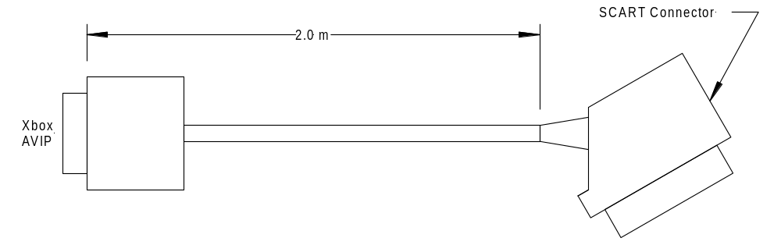
Figure 25 Standard SCART AV pack mechanical layout
This AV pack may be dropped from the final list of AV pack variations pending marketing input.
Enhanced NTSC AV Pack
The enhanced NTSC AV pack connects to the AV interface port of the Xbox console and provides output suitable for low-end consumer home theater, including S-video output and optical SP-DIF output for digital sound. The enhanced NTSC AV pack retains the composite video and linear audio outputs as well, to accommodate various system configurations.
Additionally, the enhanced NTSC AV pack supports the use of headphones for private listening.
When headphones are used, the line and SP-DIF outputs are not muted.
The outputs of the enhanced NTSC AV pack are as follows:
- Composite video out—one consumer video phono-type jack.
- Analog audio out (left)—one consumer audio phono-type jack.
- Analog audio out (right)—one consumer audio phono-type jack.
- S-video out—one DIN-4 consumer S-video output jack.
- SP-DIF digital audio output—one jack for optical output of SP-DIF digital audio out. The connector will comply with EIAJ CP-1201.
- Headphone out—one 3.5-mm stereo jack for connecting a pair of 20-ohm headphones.
- Volume control—two momentary type push buttons to increase and decrease volume levels.
The enhanced NTSC AV pack is constructed using “lump on a line” construction, in that the AVIP connector of the Xbox console terminates to a cable assembly, which in turn terminates into a breakout box containing the AV connectors listed previously.
The cable assembly connecting the AVIP plug to the breakout box consists of an over-molded assembly of individual conductors. The composite and S-video signals (V, Y, and C) are carried on coaxial cable with 75-ohm characteristic impedance (UL 1354 or equivalent). The left and right audio signals are carried on spiral-shielded cable (UL 1185 or equivalent). The remaining conductors are stranded wire, 26 AWG (UL type 1007? or equivalent).
The mechanical layout and schematic of the enhanced NTSC AV pack are shown in figure 26.
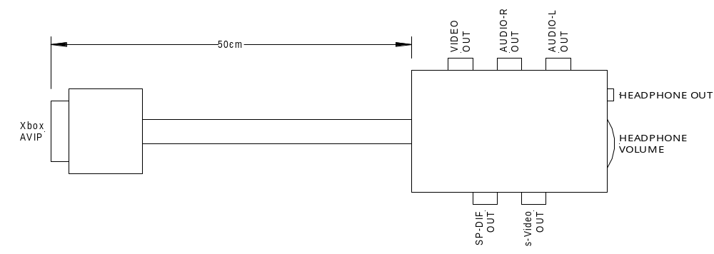
Figure 26 Enhanced NTSC AV pack mechanical layout
Enhanced SCART AV Pack
The enhanced SCART AV pack for the European market provides a means of attaching the Xbox game system to a television monitor with SCART input. The SCART connector conforms to the electrical interface and impedances described in EN 50049-1 and is upwardly compatible with the chain interconnection system described in EN 50157-2-1. The SCART plug is designed to plug into a Type I SCART port on a television monitor or other audio/video equipment.
The enhanced SCART connector outputs stereo audio and video, which may be selected from one of three modes; composite video, S-video, or RGB. Upstream aspect ratio is controlled by outputting one of three voltages on the STATUS/ASPECT RATIO pin of the SCART connector as specified in EN50049-1.
In addition to the 21-pin SCART connector, the enhanced SCART AV pack also provides an optical SP-DIF connector for digital audio and a headphone amplifier as described in the Enhanced NTSC AV Pack section.
- Type II SCART plug—one 21-pin plug conforming to EN 50049-1. This connector carries linear left and right audio and S-video.
- SP-DIF digital audio output—one jack for optical output of SP-DIF digital audio out. The connector will comply with EIAJ CP-1201.
- Headphone out—one 3.5-mm stereo jack for connecting a pair of 20-ohm headphones.
- Volume control—one rotary volume control for adjusting the headphone volume.
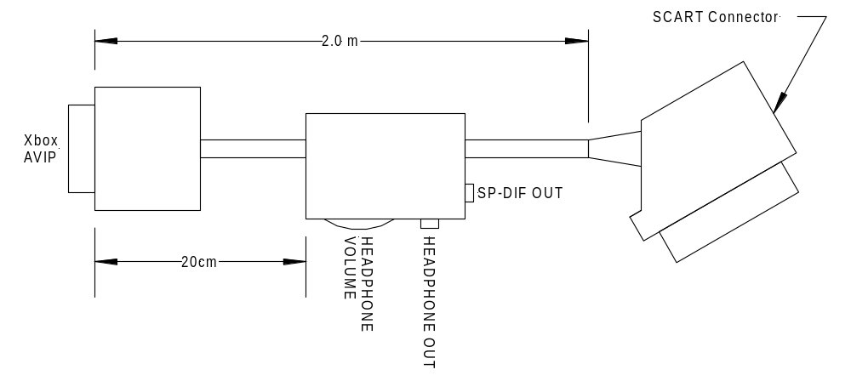
Figure 27 Enhanced SCART AV pack mechanical layout
NTSC Video RF Unit AV Pack
The NTSC video RF unit is an AV connector pack that provides an RF-modulated television signal for connection to an NTSC television ANT input. This module is localized to the region in which the AV pack is sold; the NTSC countries are listed in table 14.
The RFU module takes as inputs the composite video and mono audio signals from the AVIP connector and outputs a single RF-modulated signal via an RF connector. The module must have a channel select switch that selects one of two channels to modulate onto.
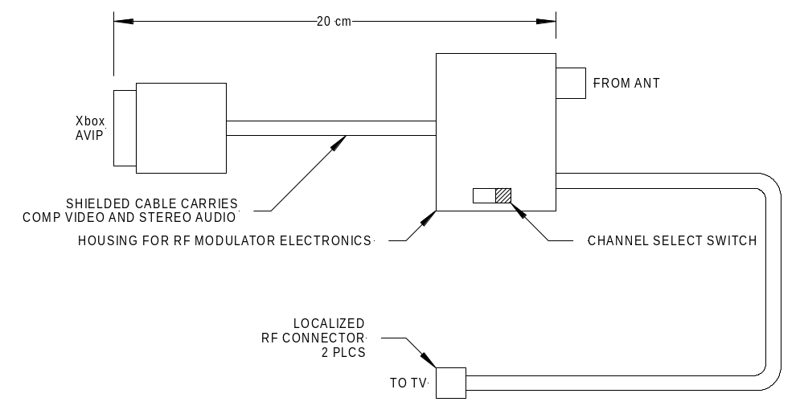
Figure 28 NTSC Video RF unit AV pack
Table 14 NTSC Video RF unit localization
Market | Television Format | Channels | Connector
USA | NTSC/M  (525 lines 29.97 f/s) | VHF 3 or 4  selectable by switch | F-type coaxial
Canada | NTSC/M  (525 lines 29.97 f/s) | VHF 3 or 4  selectable by switch | F-type coaxial
Mexico | NTSC/M  (525 lines 29.97 f/s) | VHF 3 or 4  selectable by switch | F-type coaxial
Japan | NTSC  (525 lines 29.97 f/s) | VHF 3 or 4  selectable by switch | F-type coaxial

PAL Video RF Unit AV Pack
The PAL video RF unit is an AV connector pack that provides an RF-modulated television signal for connection to a PAL television ANT input. This module is localized to the region in which the AV pack is sold. In Europe there are four modulation formats: PAL-I, PAL B/G, PAL-B/H, and SECAM-L. Table 15 shows the modulation format by country.
The RF unit module takes as inputs the composite video and mono audio signals from the AVIP connector and outputs a single RF-modulated signal via an RF connector. The module must have a channel select switch that selects one of two channels to modulate on to.
Refer to figure 28 for the mechanical layout of the PAL RF unit, as it is identical to that of the NTSC RF unit except for the style of the RF connector. The electrical schematic is identical to the NTSC RF unit except for the pin location of the jumper wire.
Table 15 Video RF unit localization
Market | Television Format | Channels | Connector
United Kingdom  Ireland | PAL-I  (625 lines 25 f/s) | VHF 3 or 4  selectable by switch | 9.5-mm coaxial
France | SECAM-L  (625 lines 25 f/s) | VHF 3 or 4  selectable by switch | 9.5-mm coaxial
Germany  Spain  Italy  Netherlands  Norway  Sweden  Finland  Austria  New Zealand | PAL-B/G  (625 lines 25 f/s) | VHF 3 or 4  selectable by switch | 9.5-mm coaxial
Luxembourg | PAL-B/G  SECAM-L  (625 lines 25 f/s) | VHF 3 or 4  selectable by switch | 9.5-mm coaxial
Belgium | PAL-B/H  (625 lines 25 f/s) | VHF 3 or 4  selectable by switch | 9.5-mm coaxial

Appendix A – System Memory Map

Appendix C – Television Systems Used By Country
Country | Television System | Lines | Field Rate (Hz)
United States | M / NTSC | 525 | 59.94
Canada | M / NTSC | 525 | 59.94
Mexico | M / NTSC | 525 | 59.94
Japan | M / NTSC | 525 | 59.94
United Kingdom | I / PAL | 625 | 50
Ireland | I / PAL | 625 | 50
France | L / SECAM | 625 | 50
Germany | B / PAL  G / PAL | 625 | 50
Spain | B / PAL  G / PAL | 625 | 50
Italy | B / PAL  G / PAL | 625 | 50
Belgium | B / PAL  H / PAL | 625 | 50
Netherlands | B / PAL  G / PAL | 625 | 50
Luxembourg | B / PAL  G / PAL  SECAM-L | 625 | 50
Norway | B / PAL  G / PAL | 625 | 50
Sweden | B / PAL  G / PAL | 625 | 50
Finland | B / PAL  G / PAL | 625 | 50
Australia | B / PAL  G / PAL | 625 | 50
New Zealand | B / PAL  G / PAL | 625 | 50
Source: ITU-R BT.470-4 Appendix I to Annex I
Appendix D – Video Waveform Timing
480-line NTSC Waveforms (640 × 480)

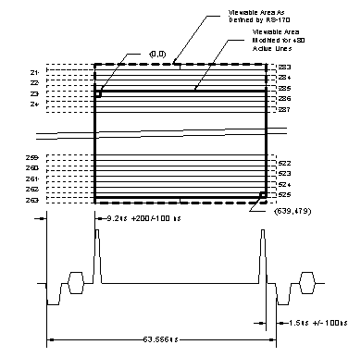
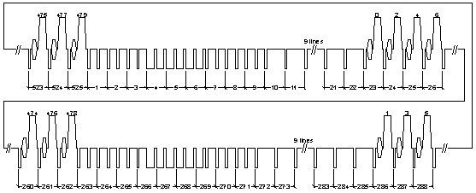
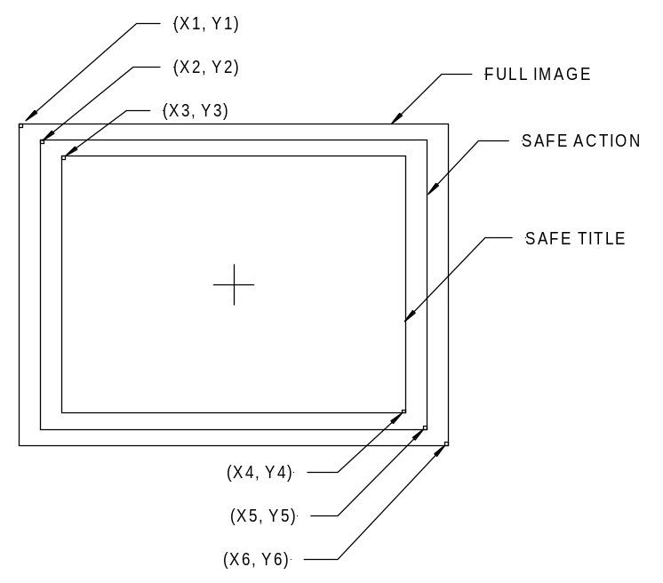Appendix E – Safe Action and Safe Title Guidelines

Frame Mode | Full Image |  |  |  | Safe Action |  |  |  | Safe Title
Frame Mode | X1 | Y1 | X6 | Y6 | X2 | Y2 | X5 | Y5 | X3 | Y3 | X4 | Y4
640x480 | 0 | 0 | 639 | 479 | 32 | 24 | 608 | 456 | 64 | 48 | 576 | 432
720x480 | 0 | 0 | 719 | 479 | 36 | 24 | 684 | 456 | 72 | 48 | 648 | 432

